The Punic Wars
The Punic Wars were a series of conflicts fought between the forces of ancient Carthage and Rome between 264 BCE and 146 BCE. The namePunic comes from the word Phoenician (Phoinix in the Greek,Poenus from Punicus in Latin) as applied to the citizens of Carthage, who were of Phoenician ethnicity. As the history of the conflict was written by Roman authors, they labeled it 'The Punic Wars'. Carthage grew from a small port-of-call to the richest and most powerful city in the Mediterranean region before 260 BCE. She had a powerful navy, a mercenary army and, through tribute, tariffs, and trade, enough wealth to do as she pleased. Through a treaty with the small city of Rome, she barred Roman trade in the Western Mediterranean and, as Rome had no navy, was able to easily enforce the treaty. Roman traders caught in Carthaginian waters were drowned and their ships taken.

FIRST PUNIC WAR
As long as Rome remained the little city of trade by the Tiber River, Carthage reigned supreme; but the island of Sicily would be the flashpoint for growing Roman resentment of the Carthaginians. Sicily lay partly under Carthaginian and partly under Roman control. When Heiro II of neighboring Syracuse fought against the Mamertines of Messina, the Mamertines asked first Carthage and then Rome for help. The Carthaginians had already agreed to help and felt betrayed by the Mamertines’ appeal to Rome. They changed sides, sending forces to Hiero II. The Romans fought for the Mamertines of Messina and, in 264 BCE, Rome and Carthage declared war on each other for the control of Sicily.
IN 264 BCE, ROME AND CARTHAGE DECLARED WAR ON EACH OTHER FOR THE CONTROL OF SICILY.
Although Rome had no navy and knew nothing of sea battles, they swiftly built and equipped 330 ships. As they were far more used to fighting land battles, they devised the clever device of the corvus, a moveable gangplank, which could be attached to an enemy’s ship and held in place with hooks. By immobilizing the other ship, and attaching it to their own, the Romans could manipulate a sea engagement through the strategies of a land battle. Even so, they lacked the expertise at sea of the Carthaginians and, more importantly, were lacking a general with the skill of the Carthaginian Hamilcar Barca. Hamilcar was surnamed Barca (meaning `lightning’) because of his speed in attacking anywhere and the suddenness of the action. He struck without warning up and down the coast of Italy destroying Roman outposts and cutting supply lines.
Had the Carthaginian government better supplied and reinforced Hamilcar, they most probably would have won the war but, instead, they contented themselves with hoarding their wealth and trusted to Hamilcar and his mercenaries to take care of the war. He defeated the Romans at Drepana in 249 BCE but then was forced to withdraw due to a lack of man power and supplies. According to the historian Durant, “Worn out almost equally, the two nations rested for nine years. But while in those years Carthage did nothing…a number of Roman citizens voluntarily presented to the state a fleet of 200 men-of-war, carrying 60,000 troops.” The Romans, more experienced at sea battles now and better equipped and led, won a series of decisive victories over Carthage and in 241 BCE the Carthaginians sued for peace.
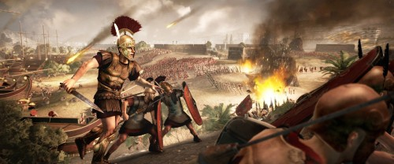
Roman Beach Attack

This war was costly to both sides but Carthage suffered more seriously owing to the corruption and incompetence of her government (which embezzled funds which should have gone to the military and consistently refused to send much needed supplies and reinforcements to generals in the field), the mostly mercenary army (who often simply refused to fight), and an over-reliance on the brilliance of Hamilcar Barca. Further, however, they seriously underestimated their enemy. While Carthage would largely ignore the war, leaving the fighting to Hamilcar and his mercenaries, Rome would be building and equipping more ships and training more men. Even though Rome had never had a navy before the First Punic War, they emerged in 241 BCE as masters of the sea and Carthage was a defeated city.
During the war, the Carthaginian government had repeatedly failed to pay its mercenary army and, also in 241 BCE, these mercenaries laid siege to the city. Hamilcar Barca was called upon to raise the siege and did so, even though Carthage had refused him the much needed supplies and reinforcements on his campaigns on her behalf and he had led most of these mercenaries in battle himself. The Mercenary War lasted from 241-237 BCE and, while Carthage was engaged in this conflict, Rome occupied the Carthaginian colonies of Sardinia and Corsica. While Carthage was unhappy with this development, there was little they could do about it. They concentrated their efforts on the conquest of Spain rather than trying to drive the Romans out of their former colonies.
In 226 BCE the Ebro Treaty was signed between Carthage and Rome agreeing that the Romans would hold Spanish territory north of the Ebro River, Carthage would hold the area they had already conquered south of the river, and neither nation would cross the boundary.

SECOND PUNIC WAR
To the south of the border lay the city of Saguntum, a Roman ally, and, in 219 BCE, the great Carthaginian general Hannibal (Hamilcar’s son) lay siege to the city and took it. The Romans objected to this attack and demanded that Carthage deliver Hannibal to Rome. The Carthaginian senate refused to comply and so began the Second Punic War (218-202 BCE).
Hannibal, a sworn enemy of Rome, received intelligence that Roman armies were moving against him and, in a bold gamble, marched his forces over the Alps and into northern Italy. Hannibal then proceeded to win every single engagement against the Romans, conquering northern Italy and gathering former allies of Rome to his side. Having lost many of his elephants on his march over the mountains, and lacking necessary siege engines and troops, Hannibal was caught in southern Italy in a cat and mouse game with the Roman army under Quintus Fabius Maximus. Fabius refused to engage Hannibal directly relying, instead, on cutting off his supplies and starving his army.
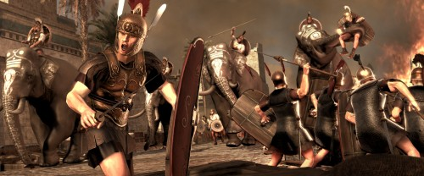
Carthaginian War Elephants

Fabius’ strategy might have worked had not the Romans become impatient with their legions’ inactivity. Further, Hannibal used counter-intelligence to reinforce and spread the rumor that Fabius refused to fight because he was in the pay of the Carthaginians. Fabius was replaced by Caius Terentius Varro and Lucius Aemilius Paulus who threw off caution and led their troops against Hannibal in the region of Apulia. At the Battle of Cannae in 216 BCE, Hannibal placed his Gauls in the center of his lines, expecting they would give way before the Roman forces. When they did exactly that, and the Romans pressed what they saw as an advantage and followed them, Hannibal closed from behind and the sides, enveloping the Roman forces and crushing them. 44,000 Roman soldiers died at Cannae compared with 6000 of Hannibal’s forces. Hannibal won his greatest victory but could not build upon it as Carthage refused to send him the reinforcements and supplies he needed.
Shortly after this, the Roman general, Publius Cornelius Scipio (later known as Scipio Africanus, who had fought against Hannibal at Cannae) was defeating the Carthaginian forces in Spain (under Hannibal’s brother, Hasdrubal). Recognizing that Hannibal’s army would be recalled if Carthage were attacked, Scipio manned a fleet and sailed to North Africa where he took the Carthaginian city of Utica. Carthage recalled Hannibal from Italy to save their city but Scipio was a great admirer of Hannibal and had studied his tactics carefully. At the Battle of Zama in 202, Hannibal sent an elephant charge against the Romans which Scipio, mindful of Hannibal’s strategies, deflected easily. The Romans killed the Carthaginians on the elephants and sent the animals back into the Carthaginian ranks, then followed with a combined cavalry charge and infantry advance which caught the enemy between and crushed them. Hannibal returned to the city and told the senate that Carthage should immediately surrender.
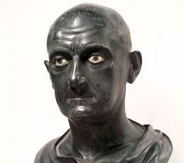
Scipio Africanus

Scipio allowed Carthage to retain her colonies in Africa but she had to surrender her navy and was not allowed to make war under any circumstances without Rome’s approval. Carthage was also to pay Rome a war debt of 200 talents every year for fifty years. Carthage was, again, a defeated city but, retaining its trading ships and ten warships to protect them, was able to struggle on and begin to prosper. The Carthaginian government, however, still as corrupt and selfish as it had always been, taxed the people heavily to help pay the war debt while they, themselves, contributed nothing. Hannibal came out of retirement to try to rectify the situation, was betrayed by the rich Carthaginians to the Romans, and fled. He died by his own hand, drinking poison, in 184, aged sixty-seven.

THIRD PUNIC WAR
Carthage continued paying the war debt to Rome for the proscribed fifty years and, when it was done, considered their treaty with Rome completed also. They went to war against Numidia, were defeated, and had to then pay that nation another war debt. As they had gone to war without Rome’s approval, the Roman senate considered Carthage a threat to the peace again.
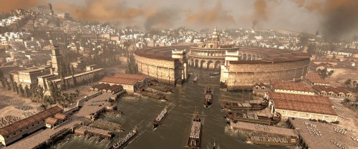
Carthage and its Harbour

The Roman senator Cato the Elder took the threat so seriously that he would end all of his speeches, no matter the subject, with the phrase, “And, further, I think that Carthage should be destroyed.” In 149 BCE Rome sent an embassy to Carthage suggesting exactly that course: that the city should be dismantled and moved inland away from the coast. The Carthaginians refused to comply with this and so began the Third Punic War (149-146 BCE).
The Roman general Scipio Aemilianus besieged the city for three years and, when it fell, sacked it and burned it to the ground. Rome emerged as the pre-eminent power in the Mediterranean and Carthage lay in ruin for over one hundred years until it was finally re-built following the death of Julius Caesar. The Punic Wars provided Rome with the training, the navy, and the wealth to expand from a small city to an empire which would rule the known world.

