World History
Mr. Murray
Study Guide: Ancient Greece

Identfication: Who? What? Where? Why important?
- 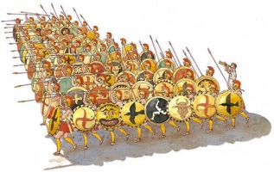

- 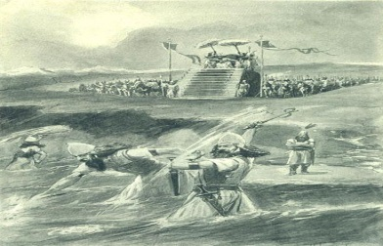

- 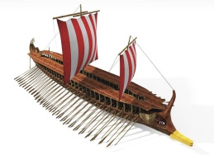

People, Groups, Events, Concepts

Mycenaean’s

Minoans

Linear A

Linear B

Trojan War

Homer

Epics
Name:
Date:
Block:

Iliad

Odyssey

Menelaus

Helen

Achilles

Hector

Agamemnon

Odysseus

Dorians

Script Theory

Arete

Polis

Acropolis

Hoplites

Aristocracy

Oligarchy

Tyrants

Democracy

Athens

Sparta

Draco

Solon

Cleisthenes

Helots

Olympic Games

Ephors

Council of Elders

Phalanx

Persian Wars

Ionian Revolt

King Darius

Battle of Marathon

Pheidippides

Themistocles

Xerxes

The Immortals

Battle of Thermopylae

Battle of Salamis

Battle of Plataea

Delian League

Pericles

Pericles Funeral Oration

Ostracism

Phidias

Classical art

Tragedy

Comedy

Herodotus

Peloponnesian War

Philosophers

Socrates

Plato

Aristotle

Pythagoras

Archimedes

Hippocrates

Short Answer
What impact did nearness to the sea have on the development of Greece?

Why were the epics of importance to the Greeks of the Dorian period(Dark Age)?

Explain the contributions of Draco, Solon and Cleisthenes to the Athenian political system?

How did Athens benefit from the victory in the Persian Wars?

Why was the Battle of Themapolae pivotal battle in the second Persian War?

How was living in Athens different from living in Sparta?

What steps did Pericles take to strengthen democracy in Athens?

What were the battle strategies of Athens and Sparta in the Peloponnesian War?

Why do you think some Athenians found the ideas of Socrates so disturbing?

How did the Peloponnesian Wars bring an end to the Golden Age of Ancient Greece?

