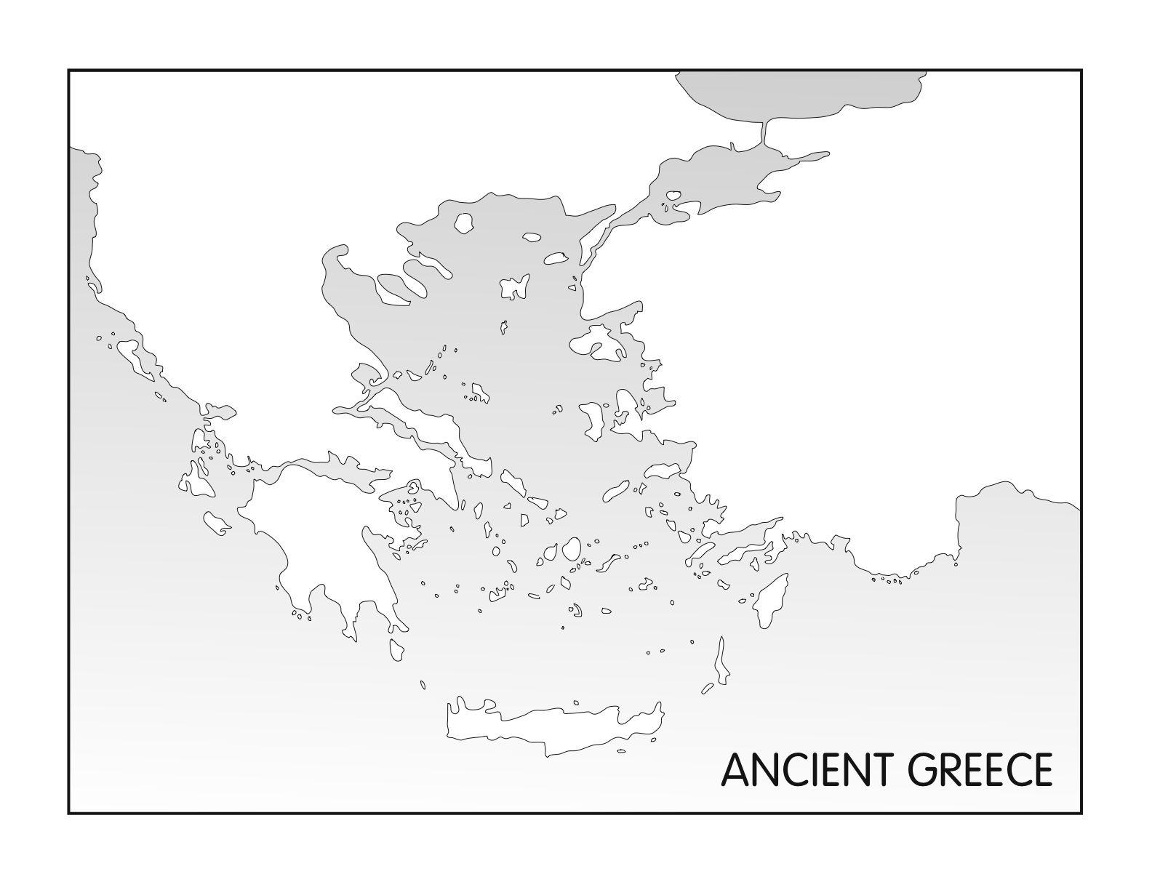

Directions for Ancient Greece Map: Using the Classical Greece map on page 7 of the historical atlas label the following on your map.
- Territories: (Color different colors) Attica, Laconia, Messenia, Macedon, Ionia
- Cities: (Mark with a dot) Sparta, Athens, Thebes, Corinth, Olympia, Delphi, Cnossus (Crete), Miletus
- Major Battle Locations: (Mark with an X) Chaeronea, Plataea, Marathon, Thermopylae, Salamis
- Bodies of Water: Ionian Sea, Cretan Sea, Gulf of Corinth, Aegean Sea, Black Sea, Bosporus Strait, Hellespont
- Island of Importance: Lesbos, Samos, Rhodes, Crete, Melos
- Mountains: (Mark with an X) Mount Olympus, Artemisium

