American History
Mr. Murray
Sources: Scott Miller, The President and the Assassin: McKinley, Terror, and Empire at the Dawn of the American Century (2011); Kenneth C. Davis, Don’t Know Much About History (2003)

What was the Spanish-American War Really All About?
By the late 1800s, a new ideology was taking the world by storm. Countries in Europe began expanding through the conquest of territories in Africa and Asia. Their conquests afforded them not only with more territory, but more resources, more money, and more power. European imperialism reached its height in the late 1800s. Imperialism is when stronger nations attempt to create empires by dominating weaker nations economically, politically, culturally (socially), or militarily. Previously operating under a policy of isolationism (a policy of avoiding political or economic alliances with foreign countries), the United States was late to arrive in the race to imperialize. By that time, most of Africa and Asia had already been carved up by European powers, without their consent and without care or concern to local customs, local allegiances, or local conflicts. Despite their late arrival, the United States was sure to make a big impression on the ever-changing world.
As part of our newly found desire to gain new territories, the U.S. Navy also found it necessary to expand. Captain Alfred T. Mahan, an influential naval officer, wrote The Influence of Sea Power Upon History, 1660-1783 and argued that the nation’s economic future rested in its ability to expand and find new markets within which to sell our goods. In order to do so, the U.S. would need a strong military to protect our interests abroad. By the time Mahan’s book was published in 1890, the U.S. had already begun to take action. Congress authorized the building of three cruisers and two battleships, including the U.S.S. Maine. The Naval Act of 1890 extended this notion by calling for the construction of more battleships, gunboats, torpedo boats, and cruisers. By 1900, the United States navy rivaled the most powerful navies in the world.
It soon became evident that if the U.S. were to expand then China, Latin America, and the Pacific would be our best options. China, interestingly enough, was wide open. It lacked modern factories and inventions and, for the most part, was an untapped market. President McKinley also noticed the value in a small island in the Pacific. Hawaii was a naval dream. Its location provided a pivotal point between the United States and China; Hawaii would serve as a way for the U.S. to control trade routes in the Pacific, and its location made for a wonderful refueling stop between the U.S. and China. After a military intervention, Hawaii was annexed by the U.S. in 1898. But what about Latin America?
By the 1890s, all that was left of Spain’s once-powerful empire were Cuba, the Philippines, and Puerto Rico. Cuba was known by the Spaniards as “the ever faithful isle.” Consisting mostly of sugar plantations, Cuba was a huge economic benefit to Spain. But “the ever faithful isle” was constantly in revolt; the Spanish treatment of Cuba was harsh and oppressive. The Cubans revolted in the mid-1890s by trying to destroy their own economy; if they could bleed the Spanish dry of any funds, then maybe the Spanish would leave and Cuba could operate independently of Spanish rule. The immediate goals were a success: the value of the sugar crop went from $62.1 million in 1894 to $13 million in 1896. The long-term effects of this, however were devastating. Widespread poverty and violence soon plagued “the ever faithful isle.”
Spain responded by sending a vicious military general to suppress the rebellion. Known as “the Butcher,” General Valeriano Weyler Nicolau crushed the rebellion by use of a program known as La Reconcentración, in which men, women, children, and elderly were rounded up and placed in camps for constant monitoring. Conditions in the camps were atrocious; food shortages, poor sanitation, and violence were key elements of the camps. The horrendous conditions turned the prisoners into animals; fighting for survival was a constant, and many of the prisoners wanted the dirty city streets in search of any edible scraps to nourish their emaciated and starving bodies.
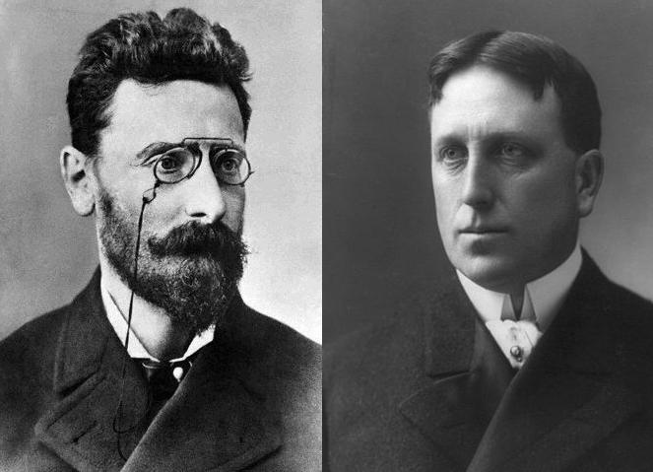
So how did the United States get involved in a colonial war of seemingly no consequence to themselves? Simple: journalism. The 1890s became a media spectacle in the United States. Two competing newspapers, the New York World and its publisher Joseph Pulitzer, and the New York Morning Journal with publisher William Randolph Hearst, were pitted against each other in a battle for journalistic supremacy. Fighting for increased circulation of their newspapers, the publishers sponsored sensationalist reporting known as yellow journalism. Such reporting was successful in riling up American support for the Cuban rebels. Americans sympathized with the Cuban rebels, with whom they identified in trying to overthrow an oppressive ruler. But despite the public sentiment and support for Cuba, President McKinley hesitated to act.
That was of course until one evening in February 1898. Five months prior, it looked as though the U.S. was on a collision course with Spain. But this did not necessarily mean in Cuba. The Philippines were a central holding for the Spanish empire. As its largest colony in the Pacific, the Philippines had been ruled by Spain for 300 years. President McKinley was again skeptical. But American military advisors made an intriguing argument: seizing the Philippine capital of Manila gave the U.S. a bargaining chip with Spain in relation to Cuba. Additionally, if the U.S. military could work with the Philippine rebels, who also had risen in rebellion against Spain, then they could gain control in the Philippines as well. To American military leaders, attack Spain in the Philippines was a win-win: get the Philippines, get Cuba. As tensions between the U.S. and Spain heated up, President McKinley decided to send the U.S.S. Maine, a warship, to the Cuban port of Havana. The decision was double-sided: 1.) riots had recently broken out in Havana and the ship would serve as some means of protection of U.S. sugar interests; 2.) under the auspices of “friendly matters” and “exchanging courtesies,” the arrival of the U.S.S. Maine showed the Spanish the power of the newly expanded American fleet.
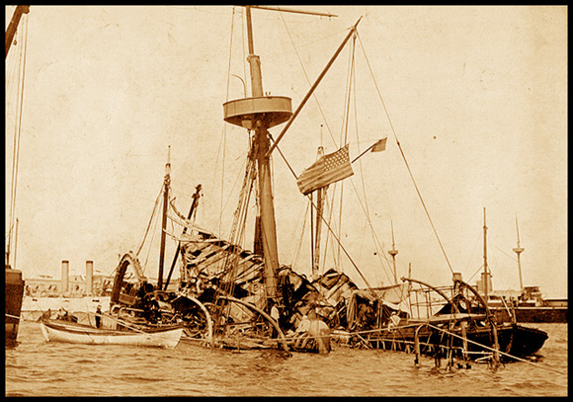
On February 15, 1898, an explosion rocked Havana Harbor. The explosion was on the U.S.S. Maine, and the ship, after first buckling in two under the force of the explosion, quickly sunk to the bottom of the harbor. Witnesses remember “a great column of fire” as the blasts instantly killed hundreds of sailors while they relaxed in their bunks. Some 266 American officers and sailors lost their lives in the explosion. Chaos ensued both in Havana and in Washington D.C. with wives, mothers, and girlfriends seeking answers to the sober New York Journal’s headline: “Cruiser Maine Blown Up in Havana Harbor.” Other Americans would begin to take notice two days later when the same Journal, despite vague details from the explosion, ran the headline: “Destruction of the Warship Maine was the Work of the Enemy.”

