World History
World Religions: Judaism, Christianity, and Islam
Source: Western Civilization, Jackson Spielvogel (2006).

Perhaps, from an outside view, the only comparison that most could make between Judaism, Christianity, and Islam is their monotheistic tradition. Every other aspect, from their founder, to their Holy Book, to their daily actions and major beliefs seem vastly different. However, a closer evaluation of these three faiths reveals that their similarities run much deeper than just their belief in the existence of one God. Their similarities should link them together and, more so than their differences, should dominate the relationship that exists between them. So the questions arise, what exacerbates their differences, and how do these differences often lead to violence and hatred? And, more importantly, do their similarities provide enough commonalities to overcome such differences?
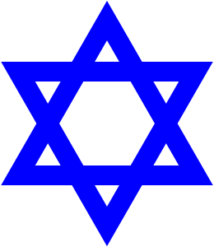
Judaism was founded around 2000 BCE. As the first Patriarch of the Jewish people, Abraham is a central figure in Judaism. Originally a leader of one of the many nomadic Hebrew clans, Abraham began to believe that there was one true God that was worthy of worship. Although he did not dismiss the existence of multiple gods, a popular belief of the Mesopotamian region at that time, he believed that there was only one true Creator with whom he and his followers had a connection with. According to the Jewish faith, God established a covenant (promise) with Abraham, promising to make Abraham the “father” of the “chosen people,” so long as they promised to obey God. Circumcision, the cutting away of the foreskin of the penis, was physical proof of the Covenant with God. Once circumcised, no Jew could ever say, “I am not a Jew.” In order to prove his faith and loyalty, Abraham was subjected to many tests, including leaving his homeland and preparing to sacrifice his son, Isaac. Later, that same God would appoint Moses as the Prophet of the Jews. Appearing to Moses in the shape of a burning bush, God instructed him to lead the Israelites out of Egypt and into Canaan. Through Moses, God was able to reveal his laws, or the Ten Commandments, to his people. The Jewish faith is explained in the Torah, also known as the Hebrew Bible. Consisting of five books, Genesis, Exodus, Leviticus, Numbers, and Deuteronomy, the Hebrew Bible is known to Christians as the Old Testament. It is this last book, Deuteronomy which tells of the “chosenness” of the Jewish people. The rest of the books, however, detail the history of the Jewish people and the path to salvation by stressing the importance of the belief in one god and the acts of good deeds, particularly in relation to the Ten Commandments:
- I am the Lord thy god, who brought thee out of the land of Egypt, out of the house of bondage.
- Thou shalt have no other gods before Me.
- Thou shalt not take the name of the Lord thy God in vain.
- Remember the Sabbath day to keep it holy.
- Honor thy father and thy mother.
- Thou shalt not murder.
- Thou shalt not commit adultery.
- Thou shalt not steal.
- Thou shalt not bear false witness against thy neighbor.
- Thou shalt not covet anything that belongs to thy neighbor.
Today, there are many divisions within the Jewish faith, including Reform, Conservative, Modern Orthodox, and Reconstructionist, among others. But, all observe the Sabbath on Saturdays and worship in a temple known as a synagogue. Jerusalem, the holiest city for followers of the Jewish faith, is the site of many ancient temples, including the Western Wall built by King Solomon in the tenth century BCE and the Temple Mount. (The Temple Mount represents the location at which Abraham was to sacrifice his son, and the Western Wall was an outer wall surrounding the Temple Mount). Sometimes referred to as the “Wailing Wall” by non-Jews, the Western Wall has served as a place of worship and prayer. Jews have strict dietary laws called kosher laws. The kosher laws forbid the eating of certain types of foods, for example, pig, rabbit, shellfish, and some types of dairy products. In Judaism, the Messiah has yet to appear and is still awaited. For this reason, Jesus is viewed as one of the many false messiahs. This is not to say that the Jews reject Jesus. For the Jews, Jesus is one of many prophets, but not the true Messiah proclaimed in the Torah. The symbol of Judaism is the Star of David that can be traced all the way back to 1100 BCE. The Star of David represented the Jewish kingdom of King David known also as “the Promised Land of Israel.”
The Christian story is deeply rooted in Jewish traditions and beliefs, since Jesus himself was a Jew. As a Palestinian Jew, Jesus grew up in Galilee in the town of Nazareth. Very little is known about the childhood of Jesus, but it would be his actions in his adulthood that would change the course of history and religion forever. Sometime during his thirties, Jesus began to follow the teachings of John the Baptist, a travelling preacher who performed baptisms in the Jordan River. Upon being baptized by John the Baptist, Jesus had a vision and began preaching his own message. Similar to the Jewish faith, Jesus believed that salvation was attained through belief in God and good acts. But, his message differed in that he preached the transformation of the inner self; Jesus believed that God’s command of His children was to love their God, and to love one another. It is here that the true identity of Jesus’ message existed. The message of Jesus stressed the importance of the individual and offered the people of his time something no other religion did: an individual relationship with God. Unpopular among most Jews and Roman officials, Jesus was denounced and crucifixion, a common punishment for criminals of the time, was ordered. Upon the story of his resurrection, followers of Jesus began to hail him as “Christ” or Greek for “anointed one.” This prophet, seen as a false prophet to Jews, became the Messiah who would return to establish the kingdom of God on earth. Worshipping on Sundays rather than Saturdays, modern Christians recognize the Torah as the Old Testament to the Christian Bible (the New Testament refers specifically to the stories and teachings of Jesus). The four gospels—Matthew, Mark, Luke, and John—help to establish the basic premises and tenets of Christian doctrine. There are many divisions within Christianity (Catholicism, Protestantism, and Orthodox, among others), but most often these divisions are created based on specific ways of practicing the religion and rarely the religion itself. The belief in the Trinity, or the belief of God as the father, the son, and the Holy Spirit, and the justification through faith are essential elements to Christian Doctrine and therefore help to bind all Christians together. For Christians, it is of the utmost importance to have faith in Jesus as the Son of God so that they can foster a relationship with God that will help them achieve the ultimate goal of eternal peace in Heaven. Jerusalem is the holiest of all Christian sites, since this is the part of the world where Jesus lived and did his work. The cross is the symbol of all Christians since, according to their beliefs, it was on the cross that Christ died for man’s sins.
While considered the father of the Jews, Abraham, or Ibrahim as he is known by Muslims, is also a central figure in Islam. For Muslims (followers of Islam), Abraham is neither a Jew, nor a Christian, nor a Muslim, but rather a person who truly believed in the existence of one God and sought to discover who that God was. Muslims believe that while the Jewish people descended from Abraham’s son Isaac, the Arab people descended from Abraham’s other (and somewhat illegitimate) son Ishmael (Isma’il in Arabic). The founding of Islam by the prophet Muhammad, a merchant from Mecca, in 610 CE represented the final revelation of God (the first two of course being partial revelations to Moses and Jesus). According to the Qur’an (or Koran), the Islamic Holy Book, Muhammad was meditating in a cave when we heard a voice commanding him to “recite.” After teaching his revelations to others, Muhammad gained a large following and thus Islam began to spread. Meaning “submission” to the will of Allah, Islam provides its followers structure and guidance for their daily lives.
The Qur’an, which means “recitation,” became the holy scriptures of Islam and contained instructions and guidelines which believers in Allah were supposed to follow. The Qur’an also includes an ethical guidebook and a code of law (which later evolved and became known as Sharia). Sharia deals with many topics addressed by secular law (non-religious law), including government, crime, and the police. Sharia also deals with personal matters such as sexual behavior, fasting, dietary laws, and individual behavior.
Forbidden Foods of Sharia Law:
- Dead meat
- Those animals slaughtered by those other than Muslims, Jews or Christians
- Food or meat prepared by non-Muslims, Jews or Christians
- The meat of beasts or prey, such as lions, dogs, etc. and those of preying birds that attack with their claws such as eagles, vultures, etc.
- The meat of domestic donkeys
- The meat of animals that feed on filthy things, except if they are isolated and fed clean food for sufficient time
- Any food spoiled by filth until it is cleaned by water, if possible
- Alcohol
- Foodstuffs containing toxic elements which are harmful to our bodies
Forbidden Behaviors of Sharia Law:
- To associate (in worship) anything or anyone with Allah
- To be disobedient to ones parents
- To give false testimony
- To kill a person whom Allah has forbidden to, except by law (legally)
- Adultery, or sex before marriage
- To steal
- To take anything, unjustly, from the property of an orphan
- To desert the battlefield while fighting unbelievers
- To falsely accuse with adultery or fornication a chaste Muslim woman or man
- To uncover “Awra” (the naked body and sexual organs) in front of anybody
- To take others’ wealth illegally, by means of bribery, robbery, trickery, or deceit.
- To bribe in order to take others’ properties illegally, or to get what you have no right to.
- To marry mother, daughter, sister, paternal aunt, maternal aunt, bother’s daughter, sister’s daughter, whether they are through blood or foster relationship, your father’s wife, your son’s wife, your wife’s mother, or daughter.
- A Muslim man is not permitted to marry a non-Muslim woman unless she becomes Muslim; be he can marry a Christian or a Jewish woman.
- A Muslim woman is not permitted to marry a non-Muslim man, even a Christian or a Jew, unless he becomes a Muslim
- To take part in gossip or scandals
The basic tenets of Islam are combined in a code known as the Five Pillars of Islam. The Five Pillars of Shahada (belief in Allah as God and Muhammad as his prophet), Salah (standard prayer five times daily), Zakat (alms or charity to the poor and unfortunate), Saum or Sawm (observing the holy month of Ramadan by fasting), and Hajj (pilgrimage to Mecca at least once in a lifetime) are strictly adhered to by all followers and believers in Islam. Other behavioral guidelines often include the prohibition of eating pork, consuming alcoholic beverages, gambling, and dishonesty. There are currently two major divisions within Islam itself: Sunni and Shi’a. These divisions, created over a conflict concerning who would lead the Muslims upon Muhammad’s death (the Sunni believed the next leader should come from an elite member in society, while the Shi’a believed it should be a descendant of Muhammad himself), has led to many conflicts and provides a clear distinction between the two groups.
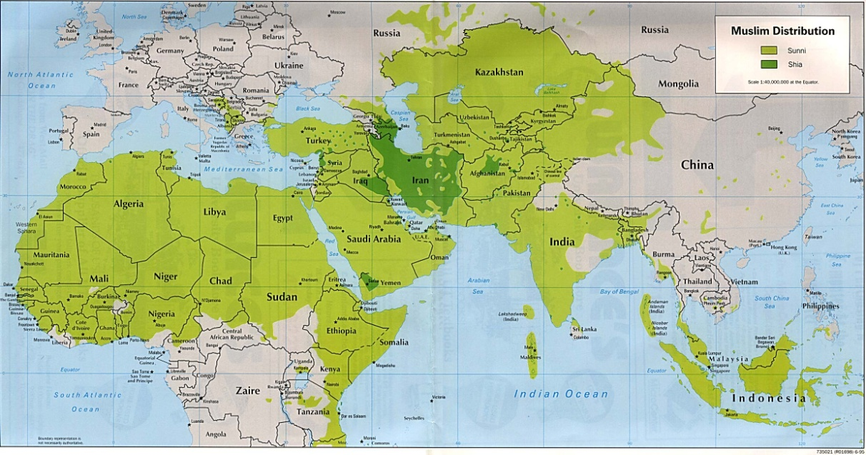
The early Muslim community did not have a symbol. During the time of Prophet Muhammad, Islamic armies and caravans flew simple solid-colored flags (generally black, green, or white) for identification purposes. In later generations, the Muslim leaders continued to use a simple black, white, or green flag with no markings, writing, or symbols on it. Beginning in the 19th century (early 1800s), the Star and Crescent symbol was associated with the Ottoman Turks, and has for many become a modern-day symbol of Islam.
The notion of three faiths with one God has historically created a situation in which religious tensions and fear have usurped harmony and understanding. So the question remains, can three faiths with the same God ever peacefully coexist?
Jihad
Jihad means ‘to strive or struggle in the way of Allah’. There are different levels of Jihad:
- Greater Jihad the personal spiritual struggle or effort of every Muslim to follow the teachings of Allah (God) in their own lives e.g. overcoming things such as anger greed, pride and hatred; forgiving someone who has hurt them; working for social justice.
- Lesser Jihad the struggle to build a good Muslim society; also Holy War (the struggle to defend against oppression; with force if necessary).
When the Prophet Muhammad was asked which people fought in the name of Allah, he said: "The person who struggles so that Allah’s word is supreme is the one serving Allah’s cause".
The idea of Jihad is often misunderstood.
Most Muslim scholars believe that the internal struggle is the greater jihad, based on something the Prophet Muhammad said. There are some scholars who believe that this is unreliable and that ‘jihad’ meaning Holy War is the more important meaning.
‘The Qur’an makes it clear that Muslims may fight in self-defence but should not start a fight or war. Other reasons for a military jihad include: to strengthen Islam; to protect the freedom of Muslims to practice their faith; to protect Muslims against attack; to put right a wrong.
“Fight in the way of Allah against those who fight against you, but begin not hostilities. Lo! Allah loveth not aggressors.’
Qur’an 2:190
A military jihad has to follow strict rules in order to be legitimate:
- The opponent must have started the fighting
- It must not be fought to gain territory
- It must be launched by a religious leader
- It must be fought to bring about good – something that Allah would approve of
- It must be a last resort – all other ways of solving the problem must have been tried
- Innocent people should not be killed; women, children or old people should not be killed or hurt
- Women must not be raped or abused in any way
- Enemies must be treated with justice
- Wounded enemy soldiers must be treated in exactly the same way as one’s own soldiers
- The war must stop as soon as the enemy asks for peace
- Property must not be damaged
- Poisoning of wells is forbidden (chemical or biological warfare might be a modern analogy).

“Hate your enemy mildly; he may become your friend one day.”
Hadith
“But if the enemy incline towards peace, do thou also incline towards peace, and trust in Allah; for He is One that hears and knows all things.”
Qur’an 8.61

