American History Name:
Date:
Sources: America, (2003) Block:

The Marshall Plan
In a February 1946 speech, Stalin predicted the ultimate triumph of communism over capitalism. Yet he knew that it would be years before the Soviets were strong enough militarily to directly confront the United States. In the meantime, Stalin called on Communists to spread their system by other means. He established the Cominform, an agency intended to coordinate the activities of Communist parties around the world. A month later, Winston Churchill responded. Although recently defeated for reelection as prime minister, Churchill remained a powerful voice of opposition to the Soviet Union. Churchill called on Americans to help keep Stalin from enclosing any more nations behind the iron curtain of Communist domination and oppression.
These two speeches of 1946—by Stalin and Churchill—set the tone for the Cold War, the competition that developed between the United States and the Soviet Union for power and influence in the world. For nearly 50 years, until the collapse of the Soviet Union in 1991, the Cold War was characterized by political and economic conflict and military tensions. The rivalry stopped just short of a “hot” war—a direct military engagement—between the two competing nations. However, United States military forces did engage in combat in other nations as part of the American effort to defeat Soviet-supported uprisings and invasions wherever they occurred.
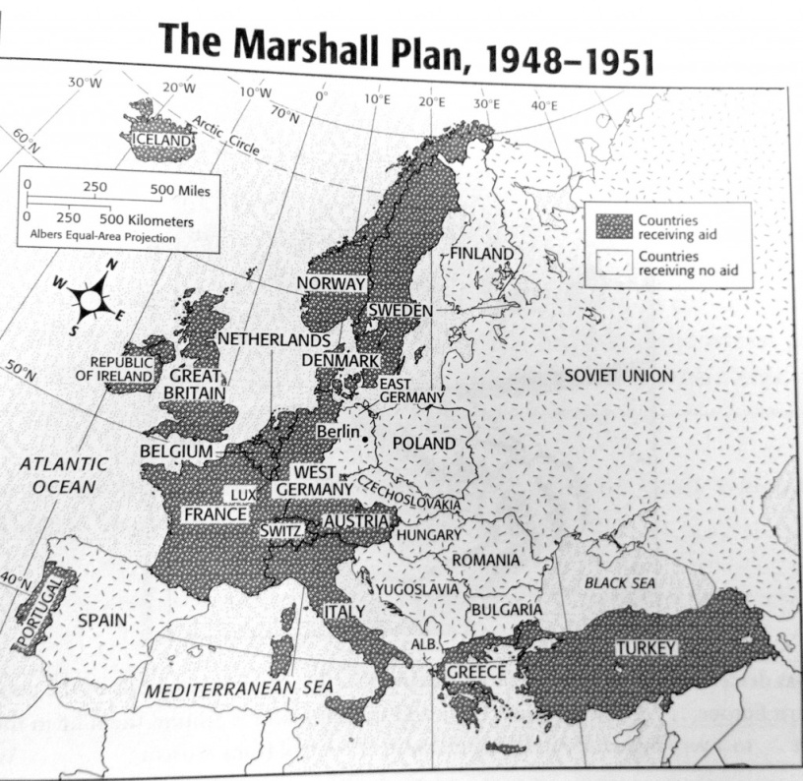
Anxiety about a “hot” and catastrophic nuclear war became a backdrop to the Cold War policies of both the United States and the Soviet Union. In addition to worrying about the new threat of nuclear war, American policymakers were determined not to repeat the mistakes of the post-World War I era. This time the United States would help restore the war-torn nations so that they might create stable democracies and achieve economic recovery. World War II had devastated Europe to a degree never seen before. About 21 million people had been made homeless. In Poland, some 20 percent of the population had died. Nearly 1 of every 5 houses in France and Belgium had been damaged or destroyed. Across Europe, industries and transportation were in ruins. Agriculture suffered from the loss of livestock and equipment. In France alone, damage equaled three times the nation’s annual income.
Marshall Plan:
These conditions led to two fundamental shifts in American foreign policy that were designed to strengthen European democracies and their economies. The first was the Truman Doctrine. The other was the Marshall Plan, which called for the nations of Europe to draw up a program for economic recovery from the war. The United States would then support the program with financial aid. The plan was unveiled by Secretary of State George C. Marshall in 1947. The Marshall Plan was a response to American concerns that Communist parties were growing stronger across Europe, and that the Soviet Union might intervene to support more of these Communist movements. The plan also reflected the belief that United States aid for European economic recovery would create strong democracies and open new markets for American goods.
The Soviet Union was invited to participate in the Marshall Plan, but it refused the help and pressured its satellite nations to do so too. Soviet Foreign Minister Vyacheslav Molotov called the Marshall Plan a vicious America scheme for using dollars to “buy its way” into European affairs. In fact, Soviet leaders did not want outside scrutiny of their country’s economy. In 1948, Congress approved the Marshall Plan, which was formally known as the European Recovery Program. Seventeen Western European nations joined the plan: Austria, Belgium, Denmark, France, Greece, Iceland, Ireland, Italy, Luxembourg, the Netherlands, Norway, Portugal, Sweden, Switzerland, Turkey, the United Kingdom, and West Germany. Over the next four years, the United States allocated some $13billion in grants and loans to Western Europe. The region’s economies were quickly restored, and the United States gained strong trading partners in the region.
NATO:
In the early postwar period, the international community looked to the United Nations to protect nations from invasion or destabilization by foreign governments, and to maintain world peace. However, the Soviet Union’s frequent use of its veto power in the Security Council prevented the UN from effectively dealing with a number of postwar problems. Thus it became clear that Western Europe world have to look beyond the UN for protection from Soviet aggression. In 1946, the Canadian foreign minister, Louis St. Laurent, proposed creating an “association of democratic peace-loving states” to defend Western Europe against attack by the Soviet Union.
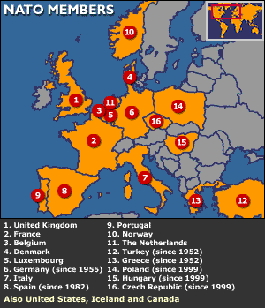
American officials expressed great interest in St. Laurent’s idea. Truman was determined to prevent the United States from returning to pre-World War II isolationism. The Truman Doctrine and the Marshall Plan soon demonstrated his commitment to making America a leader in postwar world affairs. Yet Truman did not want the United States to be the only nation in the Western Hemisphere pledged to defend Western Europe from the Communists. For this reason, a Canadian role in any proposed organization became vital to American support. In April 1949, Canada and the United States joined Belgium, Britain, Denmark, France, Iceland, Italy, Luxembourg, the Netherlands, Norway, and Portugal to form the North Atlantic Treaty Organization (NATO). Member nations agreed that “an armed attack against one or more of them…shall be considered an attack against them all.” This principle of mutual military assistance is called collective security. Having dropped its opposition to the military treaties with Europe for the first time since the Monroe Doctrine (a doctrine which initiated America’s policy of isolationism), the United States now became actively involved in European affairs. In 1955, the Soviet Union responded to the formation of NATO by creating the Warsaw Pact, a military alliance with its satellite nations in Eastern Europe.

