World History Name:

Castles, Manors, and Beginnings of Towns Date:

Synopsis of *Great Ages of Man: Age of Faith* by Anne Fremantle and the Editors of Time-Life Block:

Books (1965); and *World History: Perspectives on the Past* by Larry S. Krieger (1994)

One of the overwhelming characteristics of medieval life was how local it was compared to the Roman Empire that came before it. Under the Roman Empire, one government under one Emperor united a huge part of the world. The Roman government provided the whole Empire with a common currency, common laws, common citizenship, a common army to protect the people, a road system, trade, a pattern for establishing cities, and many other services that allowed the people to be ruled by a central government in the far away city of Rome. But the central government of Rome had failed and after 476 CE a new system of government, economics, and cultural life evolved so the people could take care of themselves at the local level. Medieval life was the opposite of Rome—there was an increasing emphasis on local protection, local government and local self-sufficiency.

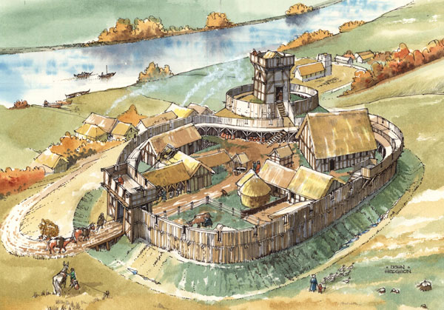Key to the defense at the local level was a simple building called a “motte and bailey” castle, which overlooked the farmlands and nearby village. The *motte*, or mound, was built with dirt dug from the ditch that constituted the fort’s outermost defense. Atop the motte rose the *keep*, a building with thick walls and slit windows that served as both watchtower and arsenal, and that contained a well at the bottom, storage and eating rooms above, and sleeping quarters on the top level. In the courtyard, or *bailey*, stood a collection of shed-like structures used as living quarters for the lord’s soldiers, shelters for their horses, and storehouses for grain and wine. The outer stone wall, which rose 10 or 12 feet above the bottom of the ditch, had only one gate reached by a fixed bridge.

Inside the wall, the keep itself was the last stronghold; equipped with water and emergency supplies, it could sustain the lord and his family, the villagers and the warriors through sieges that might last for months. The castle was a place of safety for the lord’s family and the peasants alike in a dangerous world. In the years 800 to 1000 CE, invasions from Vikings were very common all across Europe and throughout the Middle Ages lords from neighboring areas would attack each other frequently, which also created a need for forming alliances.

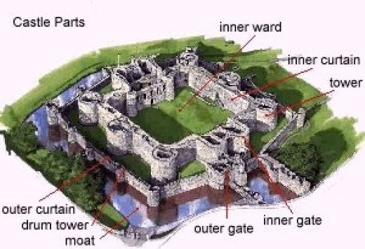Castles evolved and improved. In the late 12th and early 13th centuries, a scientific and strategic approach to castle defense emerged. This lead to more towers with an emphasis on [flanking fire](http://en.wikipedia.org/wiki/Enfilade_and_defilade) and arrow slits. Many new castles relied on “concentric” defense – several stages of defense within each other that could all function at the same time to maximize the castle's firepower. Often the ancient keep, wooden or stone, was kept in the middle of the castle as the lord expanded and added newer parts. The main feature of the concentric castle was its walls. An inner wall built of thick stone with turrets positioned at intervals was then surrounded by an equally thick but lower stone wall. The walls were built at different levels so that archers on the inner walls could fire over the archers on the outer walls. The space between the two walls was known as the 'death hole' for being trapped within the walls would almost certainly result in death for the attacker. The entire castle was then often surrounded with a moat and entry would be across a drawbridge.

Castles also became important for much more than military reasons as they became the center of life and culture. They were also symbols of power and prestige – “my castle is bigger than your castle.” Some of the most spectacular castles had long winding approach roads intended to impress and dominate their landscape.

The basic economic unit of the Middle Ages was the “manor” – a small estate from which a lord’s family gained its livelihood. A manor usually covered only a few square miles of land, perhaps with a stream meandering through it. The three biggest buildings on the manor were the castle, church, and the manor house where the lord lived. Sometimes the castle was on a hill overlooking the manor and sometimes the manor house was included within the walls of the castle. Fish from the stream or pond provided an important source of food, but about one-third of the land was used for growing grain. Another patch of land was pasture for the peasants’ oxen and the lord’s horses. The rest was forest.

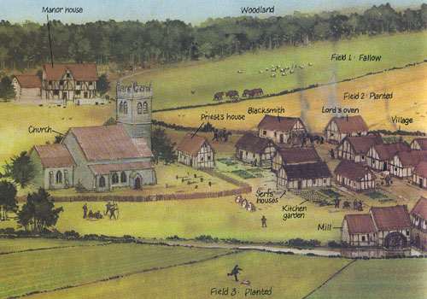

By the stream, the waterwheel of the lord’s mill turned slowly and ground the manor’s grain into flour. The millwright, who built and repaired mills, was one of several skilled workers in the village. Another was the blacksmith, who forged the few metal items used on the manor. But for the vast majority of men, women, and children the most common sight in their life was the swishing tails of oxen as they walked behind a plow in a field. Since few peasants could afford a whole team of oxen, villagers shared their animals. The same team plowed everyone’s fields. Land was shared too. Fields were laid out in long, thin strips because the plow was hard to turn. A peasant family might use strips of land scattered in fields all around the village. Peasants raised wheat, barley, oats, and rye. Coarse, black bread made from these grains was the main course of many meals. In garden patches, families grew cabbages, onions, beans, and other vegetables. Hens scratched in the dooryards of the houses, more valuable for their eggs than for meat. Half-wild pigs nosed the ground for fallen acorns near the edge of the village woodlands. One slaughtered pig per year might be a peasant family’s only source of meat so they grew adept at making sausages and using every part of the animal for benefit. Honey was used for sweetener. Fruit trees grew apples, pears, cherries, and peaches.

But life was rough for all social classes in the Middle Ages. After a bad harvest due to drought or floods starvation was disastrous. There was also the misery of being chilled to the bone when the winter winds and 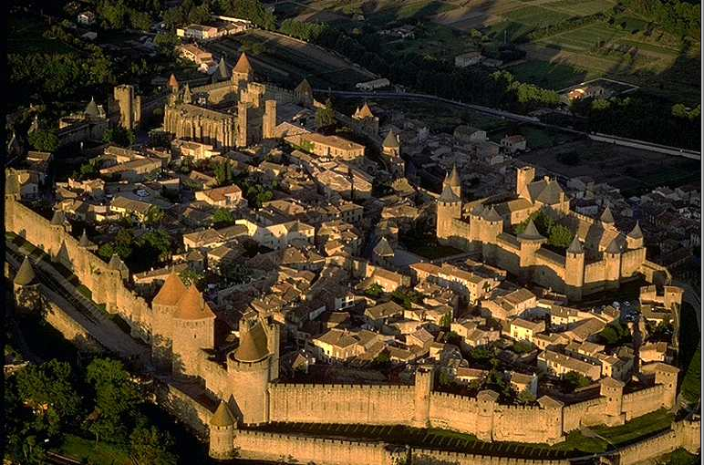snow came. The cold seeped into a peasant’s hut through cracks in the log walls. The homes had no floorboards, just dirt. There was only one room in the peasants house and parents, children, geese, sheep, pigs, and the other animals all slept together to generate enough heat to last the long night. Though often putrid and lacking privacy, warming a hut with pig heat was safer than burning a fire in the center of the room and risking that a spark would fly toward the family’s straw bed. Nobles had more to eat and warmer clothing than peasants did. Yet even nobles had little comfort from the cold in their manors or castles. And no classes had protection from the sickness, accidents, and violence which were so common in the Middle Ages.

Life on the manor again showed the overwhelming characteristic of medieval culture—it was very local. It also had to be self-sufficient and the peasants produced everything they and the lord’s family needed. There was very little trade, but salt, iron, and a few unusual objects such as millstones were purchased from the outside. Everything else—food, fuel, cloth, leather goods, lumber—was produced on the manor. The manor was thus a world unto itself.

The manor house of the lord, somewhat removed from the peasants’ dwellings, was larger and more substantially built. It consisted of a ground-level storage area with wood-floored living quarters above, possibly with a stone fireplace and chimney. Surrounding the house were storage barns, livestock stalls and a stone wall. Usually the focus of village life was the church, facing an open space where women gossiped at the well and where holiday festivities were held. In communities that did not have a castle, the church was the only stone building and served as the refuge when the village came under surprise attack.

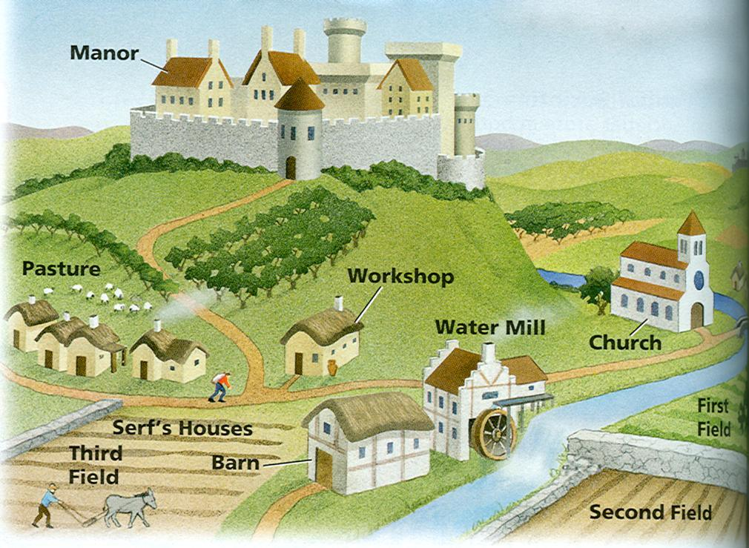Of course there was some life in the medieval culture outside the manors and in 11th Century, bigger towns began to develop in many places. The towns were “local” too and as they became independent from they too were worlds unto themselves. A town would be started by acquiring charters from kings or local lords. The “charter” documents officially granted rights that many towns had already assumed: to govern themselves, to enforce their own laws, and taxes. Town law, administered by elected officers, covered every aspect of life. With crime common in the streets, lawbreakers were mercilessly punished—hanged or decapitated for simple crimes like robbery—flogged and beaten for minor offenses. Yet the guiding spirit of town life was not one of cruelty. A new sense of local patriotism united the brawling townspeople; they built schools, hospitals, great churches, and huge defensive walls – not only to meet their needs but to glorify their town. Between 1170 and 1270, more than 500 great French churches were built in the Gothic style of architecture. Towns were moved by a feeling voiced in the charter document of one town as “let us help one another like a brother.”