American History Name:
Date:
Sources: America, (2003) Block:
1945
“I know you will not mind my being brutally frank when I tell you that I can personally handle Stalin,” President Roosevelt told Winston Churchill during World War II. “He thinks he likes me better, and I hope he will continue to.” By 1944, Roosevelt was so sure of Stalin’s cooperation that he began calling the Soviet dictator “Uncle Joe.”
A Roosevelt advisor later wrote that the President did not have “any real comprehension of the great gulf that separated their thinking.” Nor did he understand just what a wily and difficult adversary Stalin would turn out to be. Churchill, however, clearly understood the situation. “Germany is finished,” he declared. “The real problem is Russia. I can’t get the Americans to see it.”
The wartime cooperation between the United States and the Soviet Union was a temporary arrangement. There had been a history of bad feelings between two nations ever since the Russian Revolution of 1917. During that revolt, President Wilson had dispatched American troops to Russia to support anti-Communist resistance (meaning the U.S. did not support the new Communist government that was taking power). The United States had not even recognized the legal existence of the Soviet government until 1933. These actions caused considerable resentment in the Soviet Union.
As wartime allies, the Soviets disagreed bitterly with their American and British partners over battle tactics and postwar plans. The United States was angered by the nonaggression pact that Stalin had signed with Hitler (which Hitler had broken), and Stalin was angry that the Allies had not invaded Europe sooner, to take the pressure off the Russian front. As the end of the war approached, relations between the Communist Soviet Union and the two Western democracies grew increasingly tense.
In February 1945, Roosevelt met with Stalin and Churchill at Yalta to work out the future of Germany and Poland. They agreed on the division of Germany into American, British, French, and Soviet occupation zones. (Later, the American, British, and French zones were combined to create West Germany. The Soviet zone became East Germany.) Roosevelt and Churchill rejected Stalin’s demand that Germany pay the Soviet Union $20 billion in war damages.
At the meeting, Roosevelt pressed Stalin to declare war on Japan. The atomic bomb had not yet been tested, and the President wanted Soviet help if an invasion of Japan became necessary. Stalin promised to enter the war against Japan soon after Germany surrendered, in exchange for Soviet control over two Japanese islands.
Poland proved to be the most difficult issue at Yalta. The Red Army had occupied that country and supported the Communist-dominated government. Stalin opposed the return of Poland’s prewar government, then in exile in London. Historically, Poland provided an invasion route into Russia, as Hitler had just demonstrated. The Polish government, Stalin insisted, must be sympathetic to Soviet security needs. The Yalta meeting stalled until Stalin agreed on elections to let Poles choose their government, using the Communist-dominated regime as a framework. However, disputes about Poland were not over; they would continue to strain American-Soviet relations for years to come.
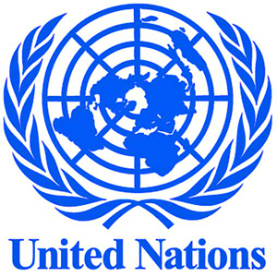
One item on which the leaders at Yalta all agreed was the creation of the United Nations (UN), a new international peacekeeping organization. The League of Nations, founded after World War I, had failed largely because the United States refused to join. This time, policymakers got congressional support for the UN. In April 1945, delegates from 50 nations met in San Francisco to adopt a charter, or statement of principles, for the UN. The charter stated that members would try to settle their differences peacefully and would promote justice and cooperation in solving international problems. In addition, they would try to stop wars from starting and “take effective collective measures” to end those that did break out. All member nations belonged to the UN’s General Assembly. Representatives of 11 countries sat on a Security Council. The United States, the Soviet Union, Great Britain, France, and China had permanent seats on the Security Council and a veto over proposed policies.
Roosevelt never lived to see his dream of the United Nations fulfilled. On April 12, 1945, just two weeks before the UN’s first meeting, the President died while vacationing at Warm Springs, Georgia. Although he was in poor health and noticeably tired, his unexpected death shocked the nation. No one was more surprised that Vice President Harry S Truman, who suddenly found himself President.
Few Vice Presidents have been less prepared to become President. Although he had spent ten years in Congress, Truman had been Vice President for only a few months. Roosevelt had never involved him in major foreign policy discussions. Truman at first seemed willing to compromise with the Soviets. But before long, his attitude hardened.
Truman’s first meeting with Stalin occurred in July 1945 in the Berlin suburb of Potsdam. During the conference, Churchill was replaced by Clement Attlee, who had just won the British election. Thus, new representatives from Britain and the United States now faced off against Stalin. They continued to debate the issues that had divided them at Yalta, including the future of Germany and of Poland. Stalin renewed his demand for war payments from Germany, and Truman insisted on the promised Polish elections. At Potsdam, Truman got word that the atom bomb had been tested in New Mexico. Hoping to intimidate Stalin, Truman told him that the United States had a new weapon of extraordinary force. Stalin, who already knew of the bomb from Soviet spies, simply nodded and said that he hoped it would be put to good use. Stalin’s casual manner hid his concern over American’s new strategic advantage.
Shortly after Truman took office, he scolded the Soviet Foreign Minister, Vyacheslav Molotov, for the Soviet Union’s failure to allow Polish elections. Molotov was offended by Truman’s bluntness. “I have never been talked to like that in my life,” Molotov protested. “Carry out your agreements and you won’t get talked to like that,” Truman snapped.
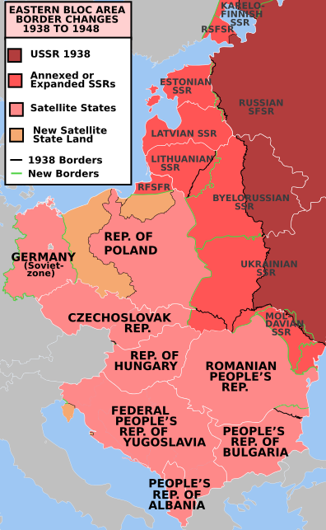
Tensions over Poland illustrated the differing views of the world held by American and Soviet leaders. Americans had fought to bring democracy and economic opportunity to the conquered nations of Europe and Asia. The United States hoped to see these goals achieved in the postwar world. An economically strong and politically open world would also serve American interests by providing markets for its products.
After losing more than 17 million people during the war and suffering widespread destruction, the Soviet Union was determined to rebuild in ways that would protect its own interests. One way was to establish satellite nations, countries subject to Soviet domination, on the western borders of the Soviet Union that would serve as a buffer zone against attacks. The Soviet Union also looked forward to the spread of communism throughout the world. According to Communist doctrine, revolution to overthrow the capitalist system was inevitable, and the role of Communist governments was to support and speed up these revolutionary processes in other countries. Stalin thus refused to cooperate with new agencies such as the World Band and the International Monetary Fund, intended to help build strong capitalist economies. Instead, Stalin installed or supported totalitarian Communist governments in Eastern Europe. Stalin gained control of Albania and Bulgaria (1948), Czechoslovakia (1948), Hungary (1947) Romania (1947), and East Germany (1945) which later became the German Democratic Republic (1949).

