American History
Mr. Murray
5. Sources: Kenneth C. Davis, Don’t Know Much About History (2003); America (2002)

Dispossession of the Plains Indians
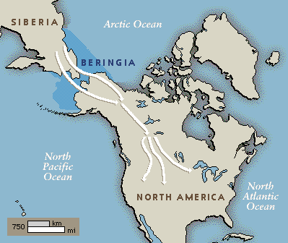
The movement west of American settlers devastated the way of the Indian. The story of their relationship with the American government is one of betrayal, brutality, and heartbreak. The origin of the American Indian is difficult to pinpoint. Stories of their origin range from a sea-faring group from the Mediterranean to being ancestors of a lost Welsh tribe. But anthropological (anthropology is the science of humanity) and archaeological evidence suggest the American Indian migrated from Asia by crossing through Beringia when a land bridge was created between Alaska and Asia during an ice age. Following herds of mammoths and other large migrating animals, the Asiatic peoples began to spread out and populate the North American continent. Living off the land for thousands of years, the way of the Indian would drastically change with the arrival of Europeans.
Contact with Europeans spelled disaster for Indians. Diseases contracted by the Europeans killed Indians in huge numbers. As more and more Europeans came to the eastern shores of the United States, many Indian tribes moved west. No longer exposed to European diseases, these Indian tribes expanded in numbers and became extremely powerful. Their move west increased their need for horses, and their need for horses made most of them nomadic. Some of the most powerful nomadic tribes were the Comanche, Lakota, and Arapaho tribes. Their skilled horsemanship and hunting culture allowed them to overpower other tribes, like the Arikara, who would then become their slaves. But, as these tribes became more powerful, they would eventually come into contact with another expanding nation, the U.S., and fights over territory would erupt.
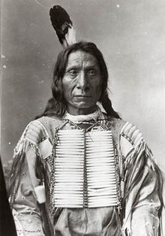
Between 1866 and 1891, the U.S. would fight many wars with the Indian tribes. Red Cloud’s War was one of the earliest. The Bozeman Trail, opened for miners to reach Montana, was built through Lakota Sioux hunting grounds. Red Cloud led the Lakota Sioux against miners. The U.S. Army stepped in and the troubles were ended with the Fort Laramie Treaty of 1868. This treaty was a major victory for the Indians. They were guaranteed ownership of the Black Hills and the territory was closed off to all whites. The Fort Laramie Treaty only lasted until Great Sioux War of 1876. Gold was found in the Black Hills territory by trespassers which caused a rush of people into the area looking to strike it rich. The U.S. government ordered miners to leave, but could not control the vast numbers of people entering the territory. The Lakota, led by Crazy Horse attacked miners and were seen as “hostiles” by the U.S. government. This then erupted into the Battle of Little Big Horn, also known as Greasy Grass, in which Crazy Horse led the Lakota against Lieutenant Colonel Custer and his troops. After a direct attack by Custer, the Lakota successfully defeated Custer by killing him and nearly all of his 250 troops. This would be the last Indian victory against the U.S. Total warfare was then launched against the Indians and movement to reservations was forced upon all Indians. 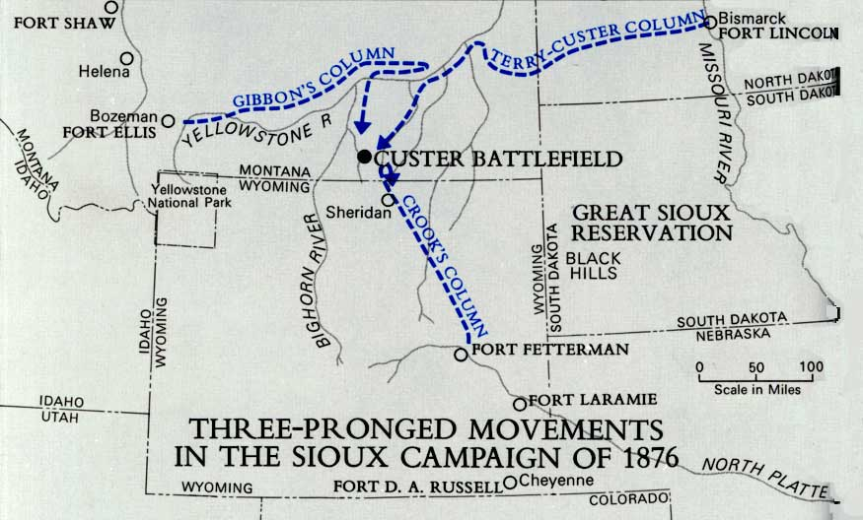
Red Cloud
Once Indians were moved onto reservations, the process of “civilizing” them began. The establishment of reservations was designed to eliminate the traditional leadership of the tribes. The U.S. government placed agents in each of the reservations to oversee the daily activities. Then came the process of assimilation, or forcing the Indian tribes to adopt American culture, customs, and attitudes. Christian missionaries were sent to Christianize the Indians. Important Indian practices, like religion and medicine, were outlawed. Polygyny, or the practice of having more than one wife at a time, was made illegal (the term polygamy can refer to either gender having more than one spouse). Traditional Indian legal practices were eliminated. The Dawes Act of 1887 attempted to make Indians private property owners by giving each family a separate plot of land (160 acres). This resulted in tremendous losses of land for American Indians and considering they had little interest in agriculture, the land became useless. In order to solidify these changes, Indian children were sent to boarding schools. Their Christian based education represented the final severing of ties to their Indian heritage
American History
Mr. Murray
6. Sources: E.H. Mullan Mental Examination of Immigrants: Administration and Line Inspection at Ellis Island (1917); Kenneth C. Davis, Don’t Know Much About History (2003)

The Immigrant Experience
Give me your tired, your poor,
Your huddled masses, yearning to breathe free
The wretched refuse of your teeming shore.
Send these, the homeless, the tempest-tost to me,
I life my lamp beside the golden door!
Emma Lazarus, 1883

It was often said that American streets were paved in gold, and during the global migrations of the 1800s, this myth was believed by many. Immigrants from all over the world had differing reasons for moving to the United States; famine, rising taxes, loss of personal freedoms, political unrest, and the potential for better opportunities were all motivations for immigration to the U.S. The quote above is from the Statue of Liberty, a sight that so many immigrants saw as they reached American shores. But the quote is somewhat misleading; most immigrants coming to the United States during the late nineteenth and early twentieth centuries were middle class citizens in their native countries. They had jobs, provided for their families, and lived a decent lifestyle. But how do their past experiences compare to their experiences in America?
The population of the United States doubled between 1860 and 1920 from 31.5 million to just over 60 million people. Two major ports, Ellis Island on the East coast and Angel Island on the West coast, welcomed immigrants into the country by inspecting and processing them. Other ports in Savannah, New Orleans, and Miami served the same purpose. While most immigrants initially settled in coastal cities, others did find their way inland, settling in the Midwest and Plains regions. What is interesting about immigrant settlements is their patterns. Irish tended to live with or near other Irish; Germans with Germans; Czechs with Czechs, Hungarians, with Hungarians, Italians with Italians.
The immigrant experience was not an easy one. Travel was dangerous and often deadly, and once they arrived, many immigrants were faced with discrimination, abuse, and the fear of starting over. Most immigrants were part of what is known as the “3rd class” or “huddled masses.” They traveled in steerage, which was a large open area beneath the ship’s deck. Traveling conditions were terrible for the 3rd class. Poor ventilation, lack of sanitation, and no privacy were typical accommodations in steerage. The 3rd class was the only class inspected for approval upon their arrival. First and second class passengers were not considered a threat to the American system and were therefore not inspected. It was believed that first and second class passengers would not become institutionalized, or be hospitalized, or become a burden on the state and therefore they were allowed into the country with relatively few restrictions. Third class passengers were different; after docking, immigrants in the third class were segregated for inspection purposes.
Line inspections were conducted by officers of the Public Health Service. Immigrants were formed into four lines in which they went through two separate medical examinations by two medical examiners. The medical examiners were trained to check 6 details with one glance: the scalp, face, neck, hands, gait, and general condition, both physical and mental. If these were hidden by clothing, the clothing would be unbuttoned or removed to ensure no abnormality existed. Hats and caps were always removed to check for any ringworm, lice, and other scalp conditions. Immigrants were also asked questions by the examiners to determine their mental state. If they could answer questions, usually name, destination, nationality, questions of addition and subtraction, they passed. If they could not, they were marked with a chalk “X” on their coat. Other designations were as follows:
B= back F= face H= heart N= neck Sc= scalp
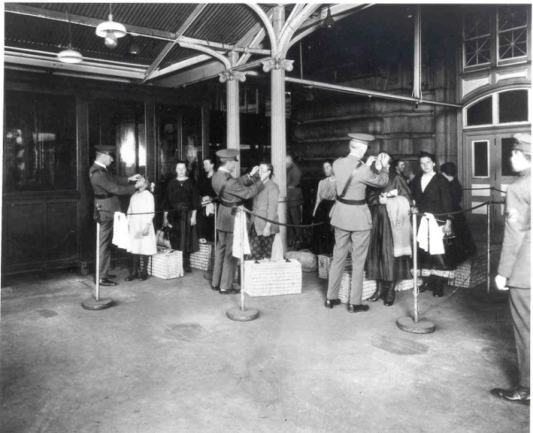
C=conjunctivitis Ft=feet K= hernia P= physical and lungs S= senility
E= eyes G= goiter L= lameness Pg= pregnancy
Once an immigrant makes it past the first examiner, he or she continues to the second examiner known as “the eye man.” This examiners job was to check for any oversights the first examiner may have missed as well as carefully examine the eyes. The second examiner usually stood in front of a large window so as to afford him enough light to give a full and complete examination. If an immigrant failed the second examination, he or she would be marked with “Vision” and taken for a third and more complete examination. If an immigrant successfully passed the second examination, he or she would move to the Upper Hall to undergo further examinations. Examinations in the Upper Hall were designed to vet the immigrants; questions were ask to make sure they were not anarchists (anti-government), bigamists (multiple spouses), paupers (poor), criminal, etc.
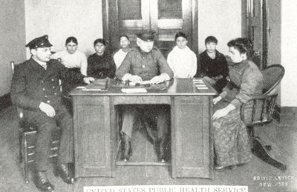
Examiners looked for specific symptoms when trying to diagnose mental fitness of immigrants. Ridiculous symptoms like facial scars, confusion, nail-biting, laughter, and forgetfulness were considered signs of mental deficiency along with more legitimate symptoms like hallucinations and nonresponsive to questions. Considering these immigrants would have been cramped in steerage for a few weeks to a few months, they would obviously exhibit some unusual signs. Many immigrants would have suffered from fatigue, their immune systems would have compromised during the trip, and many faced the difficult battle of a language barrier upon their arrival. This implies that the mental tests given by the examiners were for the most part inaccurate and therefore should have been disregarded.
The “weeding out” process was designed to handle those immigrants who received two “X” marks during the first two examinations. After receiving the second “X” immigrants were taken immediately to the mental room. Here, more mental tests were run. Immigrants were questioned further about addition, subtraction, multiplication, and spatial reasoning. If they failed, immigrants were held overnight. Any immigrant who received a “hold card” was then subjected to more tests to further weed out the deficient from the competent. Those determined to be deficient and “feeble-minded” were usually deported and sent back to their native country.
If an immigrant could make it through all of the initial tests and examinations, they were free to begin their new lives in America. However, they would continue to face trials and tribulations in their journeys to become “Americans.”

.

