American History
Mr. Murray
3- Sources: Kenneth C. Davis, Don’t Know Much About History (2003); Howard Zinn, A People’s History of the United States, 1492-Present (2003); America (2002)

The Rise of Big Business
The term “big business” refers to large-scale financial or business activities. It does not simply mean a company with a lot of capital (money), but it also includes new technology, and smart, ambitious leaders who control the company. The time period after the Civil War saw many great inventions: the typewriter, phonograph, sewing machine, the telegraph (Samuel F.B. Morse), the telephone (Alexander Graham Bell), electric power including the light bulb and electric grids controlled by central power stations (Thomas Edison, the “Wizard of Menlo Park”), and the Bessemer process, which made it easier and more efficient to use steel for building purposes. But overshadowing all of these things are the men behind the industries that grew great and powerful during the business age. Sometimes called “Captains of Industry,” these men are considered to be powerful industrialists who helped establish and expand the wealth of America. Others refer to them as “robber barons,” meaning that they were able to get rich and make fortunes by stealing from the laboring work force who helped create them. So which term is more accurate?
The four basic economic components, or resources, are land, labor, capital, and entrepreneurship. Land, referring to natural resources, labor, referring to a work force, capital, referring to man-made resources like machinery, and entrepreneurship, referring to people willing to take on new endeavors or try new things, are essential to making our economy function. When discussing “captains of industry” or “robber barons,” we are mostly talking about the entrepreneurship component. The three most significant “captains of industry” or “robber barons” are Andrew Carnegie, John D. Rockefeller, and J.P. Morgan.
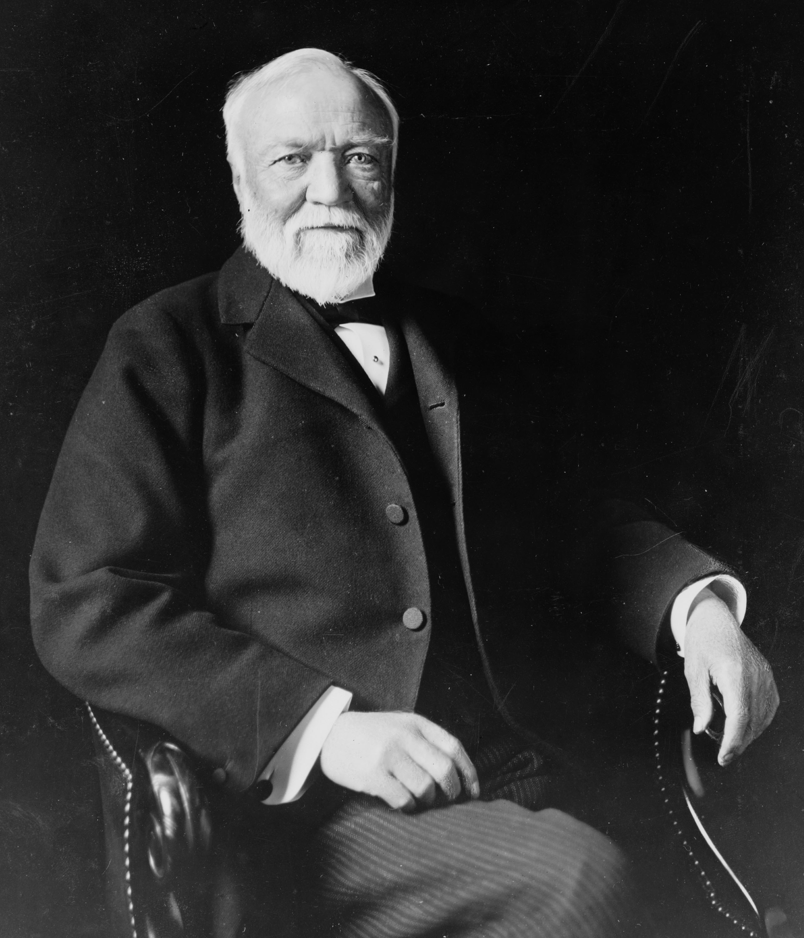
Andrew Carnegie truly is a rags-to-riches story. A Scottish immigrant, Carnegie eventually worked his way through the railroad industry to gain power of the steel industry. He had all of the qualities we see in successful businessmen: ambitious, hard-working, and able to capitalize every opportunity. After immigrating to the United States in 1848 at the age of 13, Carnegie first took a job at cotton mill. Later, he was given the job of secretary to the superintendent of the Pennsylvania Railroad Company, and when his boss took a job with the U.S. War Department, Carnegie was promoted. By 1865, Carnegie was making $50,000 a year and wanted to invest some of his money. Carnegie believed that with the development of the Bessemer process, steel would eventually become more popular than iron. In the 1870s, Carnegie created the first steel plants in Pittsburgh, Pennsylvania to use the Bessemer process. The industry exploded, Carnegie made a fortune, and in 1889 he established the Carnegie Steel Company.
Andrew Carnegie (1835-1919)
These “captains of industry” or “robber barons” used any means necessary to get ahead. They often paid very low wages for labor, and worked to pay as little as possible for resources which would maximize their profit. Often times, monopolies would develop. A monopoly is when one person or organization has complete control of a good or a service (think about playing Monopoly; the goal is to own as much of the game board as possible and to have more money than anyone else). During this time in history, most Americans believed the government should not be involved in business activity. Therefore, the government could neither tax big business, nor regulate the relationship between a business and its workers. Because of this combination, monopolies were able to flourish. One such company to benefit from this type of organization was John D. Rockefeller’s Standard Oil Company of Ohio.
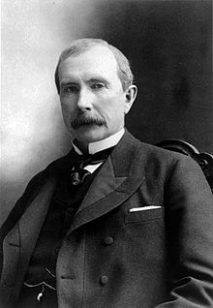
Rockefeller made his early wealth by dealing in the grain and meat industries during the Civil War. Once it was discovered that oil could be unearthed through a well, Rockefeller decided to join the oil industry in hopes of making even more money. In 1870, he established the Standard Oil Company of Ohio. Rockefeller’s true success was in how he ran his company. He had friends in the railroad industry and he was able to persuade them to give him discounts on transporting his oil. This allowed him to set Standard Oil’s prices so low that his competitors would soon be out of business. Eventually Rockefeller would be able to “buy out” his competitors. However, state laws at the time prohibited any company from owning stock in another company. So, in 1882, the owners of Standard Oil, including Rockefeller, established a “trust.” This trust would be operated by a board of trustees. The companies would give their assets to the board, and in return the board would share the profits. No laws were violated because the companies technically did not merge. Americans urged the U.S. government to take action and as a result the Sherman Anti-Trust Act was passed. This act outlawed any group of companies that acted to restrain interstate trade or commerce.
John D. Rockefeller (1839-1937)
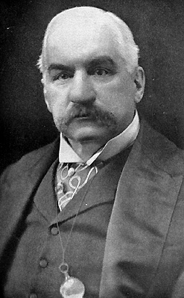
John Pierpont Morgan (J.P. for short) is another significant figure in the rise of big business. The son of a banker, J.P Morgan was able to begin making his fortune during the Civil War. Morgan managed to escape fighting in the Civil War by paying $300 to a substitute. Once the war began, Morgan purchased old, unusable rifles for $3.50 each. The rifles were then repaired and resold for $22. J.P. Morgan then began to invest in a variety of industries and eventually purchased Carnegie’s steel company for $492,000,000. Through various business deals, Morgan was able to become the financier of the times. He successfully connected the railroad industry to banks, and banks to insurance companies. By spinning a web of finance, Morgan was able to net a personal fortune of over two billion dollars.
J.P. Morgan (1837-1913)
Andrew Carnegie, John D. Rockefeller, and J.P. Morgan played a pivotal role in the growth of business and wealth in America. These men, and others, helped transform an industrial America into a developed America. Unfortunately, the personal wealth they amassed was built on the backs of the poor, ill-treated, laboring class of America.
American History
Mr. Murray
4. Sources: Kenneth C. Davis, Don’t Know Much About History (2003); Howard Zinn A People’s History of the United States (2003), U.S. Census Bureau (2010), and U.S. Bureau of Labor and Statistics (2010)

Labor Unrest, Unions, and Strikes
While American wealth soared to new heights for industrial kings like Rockefeller and Carnegie, the average American struggled to get by. Victims of high prices, low wages, and periodic depressions, the working class fell deeper and deeper into poverty. Big business was tied to the federal government and the federal government was tied to the banks creating a triangle of power and corruption. The absence of the workers from this equation would create long-lasting tensions that would eventually lead to an overhaul of the system. Big business was successful in keeping prices high, wages low, and eliminating the competition. The 1890 census showed that the wealthiest 9 percent of Americans held nearly 75 percent of the nation’s wealth, compared to today when the top 1 percent owns roughly 35 percent of the wealth (the next wealthiest class represents 20 percent of the population and holds roughly 53 percent wealth; combine the top two group in the U.S. today, and 20 percent owns upwards of 80 percent of the nation’s wealth, leaving the bottom 80 percent of Americans controlling nearly 11 percent of the wealth). These staggering gaps in wealth would spark many upheavals throughout the late nineteenth and early twentieth centuries.
The working class would only find success in improving their station in life if they became a united front against big business. Unfortunately, they were slow to organize and deeply divided across ethnic lines. The Irish and the Italians hated each other. The Germans hated the Irish. Everyone hated the Chinese, and blacks were in a league of their own. The one thing they had in common was terrible working and living conditions. The Industrial Revolution, lasting from roughly 1780 to 1880 changed the workplace; working conditions were dirty and dangerous, workers became less skilled, and day-to-day life became increasingly difficult. Eventually, American workers would find ways, violent and nonviolent, to bring attention to these issues.
Some workers in the late nineteenth century turned to a relatively new economic ideology known as socialism. Socialism is a philosophy that favors public control of property and income, not private control. This means that socialists believe society should control the nation’s wealth, not simply private individuals. Socialism insures a more even distribution of wealth across all socioeconomic groups in a society. In order to operate properly, socialism depends on society working together (cooperation) and not against each other (competition). However, for many reasons, socialism never took hold in America. Workers would have to find other solutions.
Unions: Many more Americans found success in joining together and establishing labor unions. Labor unions are organizations of workers formed to protect the interests of its members. Unions are typically formed based on trade and fight to ensure proper working conditions and hours, fair pay, and protection of the worker. One of the earliest unions, the Molly Maguires, was formed in 1875 by a group of Irish coal miners. A violent group based on creating terror, the Molly Maguires were eventually infiltrated by an informant and were accused of violence, leading to the execution of many of their leaders. Violence, therefore, would not be an acceptable means of workers getting their voices heard.
Many local unions were formed early on in American history. But as time passed, national unions began to emerge. The Knights of Labor, a national union formed in Philadelphia in 1869, worked to organize all workers, regardless of gender and skill level, into one union. The Knights of Labor fought for equal pay for equal work, an eight-hour work day, and an end to child labor. After a few failed strikes, membership dropped and the Knights of Labor disappeared by the 1890s. Another union, the American Federation of Labor, was led by Samuel Gompers. A cigar-maker by trade, Gompers was the most significant leader of the AFL. Created in 1866, the AFL differed from the Knights of Labor in that they only worked for the rights of skilled workers. Despite both fighting for wages, hours, and conditions, the Knights sought to help their members through education and political engagement while the AFL preferred to use economic means, such as strikes and boycotts, to accomplish their goals. Yet another union, the Industrial Workers of the World (IWW) focused mainly on unskilled workers. Known as the “Wobblies,” the IWW was a radical union founded in Chicago in 1905 by over 40 unions who opposed the AFL. The IWW was known for its use of violent strikes and had many socialists within the ranks of its leadership.
Many employers disliked unions; they preferred to deal with employees on an individual basis and feared the power of workers in large groups. In response to the creation of unions, employers used a variety of means to maintain control over their workers:
1. They forbade union meetings
2. They fired union organizers
3. They forced new employees to sign contracts agreeing to never join a union or participate in a strike
4. They refused to bargain collectively (a process in which workers bargain with their employers as a group, rather than as individuals)
5. They refused to acknowledge unions as the rightful representation of workers
Strikes: A strike is a forced stoppage of work intended to force an employer to meet certain demands (i.e. higher wages, shorter hours, etc.). Workers utilized this process throughout the late nineteenth century. Strikes often times led to violence. The first strike erupted in the Railroad industry in 1877. Upset about wage cuts, strikers rioted violently in multiple cities including Chicago, Pittsburgh, and St. Louis. Railroad strikes had severe consequences. Fewer workers meant that trains had to be twice as long to make up for the lost work leading to many accidents. Similarly, the number of accidents usually increased during a strike and railroad companies found it difficult to run their industry efficiently. Because of these consequences, President Hayes sent federal troops to suppress the riots, setting the precedent for federal and state troops to have the power to suppress violent strikes.
The most significant strike in the railroad industry, known as the Pullman strike, occurred in 1894. George Pullman made sleeping cars. He prided himself on being a compassionate industrialist, providing his workers with schools, banks, and water systems for comfortable living conditions. An economic panic in 1893 put industrialists on their heels. In response to the panic, Pullman laid off workers and cut wages by 25 percent while keeping costs of living and food prices at the same level. Workers went on strike when Pullman refused to deal with them. The Pullman Strike is significant for two reasons: 1.) Because it interrupted the delivery of mail, the federal government intervened and successfully halted union activity, and 2.) it set the precedent for factory workers to rely on the federal government to aid them in times of need.
The establishment of the labor unions and the use of strikes in the late nineteenth century set the stage for labor changes. Workers began to realize they were not helpless against their powerful bosses and that they had actual power. Their unity was a powerful force that their bosses did not want to deal with. These factors combined to bring up an increasingly important issue: if the government could and would help the factory owners, why couldn’t or wouldn’t they help the American worker?

