American History
Mr. Murray
Sources: Library of Congress; Kenneth C. Davis, Don’t Know Much about History (2003); Howard Zinn, A People’s History of the United States, 1492-Present (2003)

America Goes to War!
America’s imperialistic experience left it feeling secure in world affairs. Starting with control of the western hemisphere through the Monroe Doctrine (an 1823 policy in which then-President James Monroe declared that European countries were not allowed to interfere with the American continents, thus becoming the cornerstone of American foreign policy) and continuing through the acquisition of island nations in Asia and the Pacific, the United States had thoroughly exerted her power on the world stage. But when war broke out on the European continent, the U.S. was wary of getting involved. After all, the alliance system was a major factor in causing the Great War to erupt in the first place. America thought it better to stay isolated and neutral. Besides, the U.S. population was made up of immigrants from the countries who were at war; eight million German Americans had no desire to see America at war with Germany; another 4.5 million Irish Americans held no love for Great Britain, then in the midst of tightening its grip on Ireland as the Irish Republican movement was reaching its peak.
The United States declared official neutrality on August 5, 1914. However, the United States did not proceed to act neutral. Throughout the beginning stages of the war, the United States traded goods to powers at war. Trading both military and non-military goods, the United States was able to open overseas markets for American goods. Trading mostly with England and her allies, the U.S. was able to sell more than $2 billion worth of goods to countries at war. Trade expanded so much between the two that American financier J.P. Morgan began lending money to the Great Britain, which inextricably (completely) linked American finance and profits with British victory over the Germans. With vested financial interests in the outcome of the war, the U.S. was clearly no longer neutral. The tide would turn when February 4, 1915, Germany declared that all waters surrounding Great Britain were hostile, and would therefore be treated like a war zone.
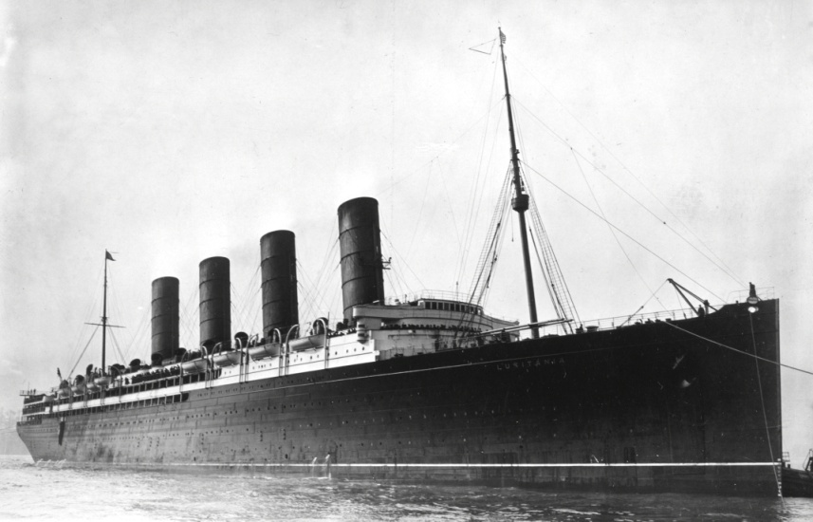
American neutrality soon became American involvement when on April 2, 1917 President Wilson asked Congress for a declaration of war. Early in May 1915, the German embassy in Washington published advertisements in American papers warning Americans to avoid sailing on British ships in the Atlantic. The German U-boat, or Unterseeboot (under sea boat), became an effective military machine. As submarines, they were most effective commercially, meaning that they frequently sunk ships carrying goods and supplies to their enemies. By torpedoing ships carrying desperately needed supplies to their enemies, the Germans could effectively undermine and weaken their enemies. On May 7, 1915, the Cunard liner Lusitania was torpedoed by a German U-boat off the coast of Ireland. In only eighteen minutes, the huge ship went down, taking with it almost 1,200 of its 1,959 passengers and crew. Among the dead were 128 Americans.
Lusitania
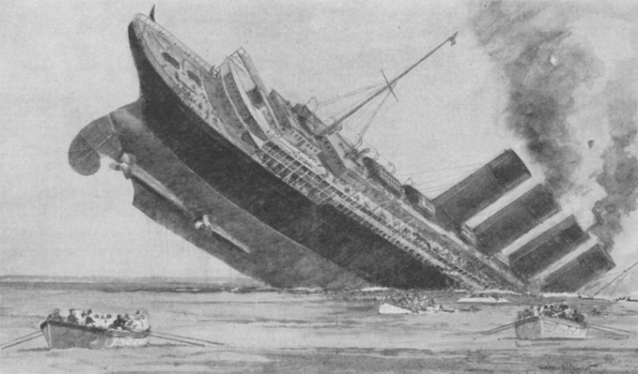
Americans began calling for war. But President Wilson stalled by attempting a diplomatic solution first. Through a series of diplomatic notes and telegrams, President Wilson attempted to strike a deal with the Germans. Urging the Germans to apologize for the act, pay reparations (damages) and a promise to not attack passenger ships in the future, the diplomatic notes were only partially successful. Germany agreed to pay reparations, but refused to apologize for the attack claiming that the Lusitania was an armed vessel and was therefore fair game for military attacks. While the British maintained the Lusitania was not armed, it was later revealed that it was indeed carrying 4,200 cases of ammunition and 1,250 shrapnel cases, which exploded when the torpedo struck, speeding up the Lusitania’s demise.
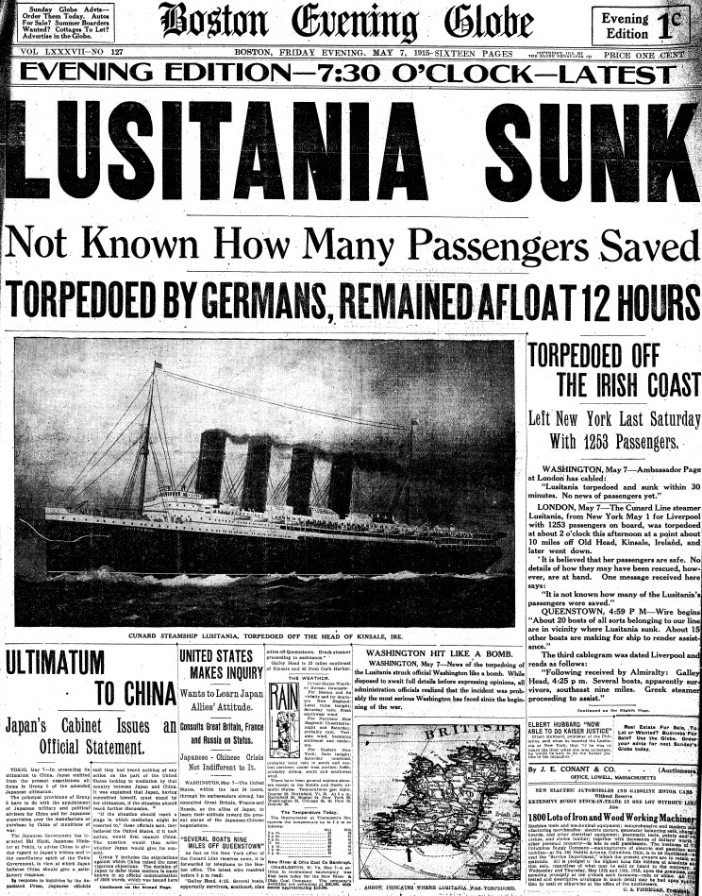
While the sinking definitely increased tension between America and Germany, the incident had little to do with drawing America into war. President Wilson continued to press his policies of neutrality while seeking to negotiate a settlement. He campaigned for reelection in 1916 under the Democratic slogan “He Kept Us Out of War.” It would be April 1917, almost two years after the sinking, before America entered the war, which was already beginning to wind down. In February 1917, the Germans began unlimited submarine warfare against all merchant shipping, including American ships, and Wilson broke off diplomatic relations with Germany. The crucial change came with the revelation of the Zimmermann Telegram, which uncovered a German plot to start a war between Mexico and the United States. British agents turned over this information to America, and when German submarines began to attack U.S. ships without warning in March, enraged Americans demanded war.
The stated reasons for America’s involvement were freedom of the seas and the preservation of democracy. But commercial interests, the expansion of overseas markets, and America’s newfound desire to compete globally with the major European powers were also at play when the United States finally went to war. On April 2, 1917, President Wilson went to Congress to ask for a declaration of war on Germany. On April 6, 1917, the U.S. declared war on Germany.

