American History Name:
Date:
Sources: (adapted from) Kenneth C. Davis, Don’t Know Much About History (2003) Block:

Hitler’s Acts of Aggression

After being appointed Chancellor in 1933, and subsequently taking full power of the German Reich in 1934, Hitler made no secret of his plans. He set his sights on systematically destroying the Versailles Treaty (made after World War I). From the start, he announced that he wanted to reunite the German-speaking people separated when the map of Europe was redrawn following the Treaty of Versailles (Lebensraum was the term used to describe expanding territory to encompass all Germans; literally “living space”). He also pledged to rearm Germany so that it would never be forced to accept terms as it had at Versailles in 1918. By 1935, Germany was committed to a massive program of militarization, modernizing its armaments and requiring universal military service.

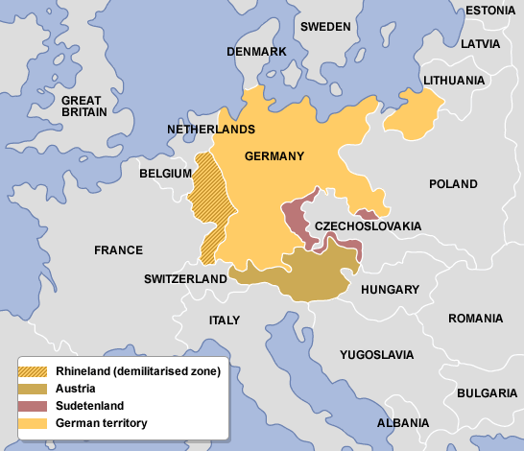
March 9, 1936: German troops moved into the Rhineland, a region in western Germany along the borders of France and Belgium. The Treaty of Versailles had expressly excluded German military forces from the region. The invasion of the Rhineland was an enormous gamble for Hitler because it clearly violated the Versailles Treaty. In addition the German Army was not yet ready to fight. Had Britain or France threatened to attack, Hitler later admitted, he would have withdrawn his forces. However, neither nation resisted him. Later that same year, Hitler and Mussolini signed an alliance, creating the Axis Powers (they would later be joined by Japan).
March 1938: Encouraged by his success with the Rhineland, Hitler then sent troops into Austria. This Anschluss, or annexation, meant that Austria was fully absorbed into Germany. Britain and France protested, but Hitler was defiant and ignored them. He argued that the people living within Austria were German, and therefore this was not a concern of either Britain or France.

September 1938: Hitler demanded the Sudentenland, a region of eastern Czechoslovakia with a heavy population of German-speaking peoples. In an effort to avoid war, representatives from England, France, Germany, and Italy met in Munich, Germany in September, 1938. Britain and France followed a policy of appeasement, or giving into someone’s demands in order to keep peace. Neither country was prepared for war, mentally or physically, and so both worked hard to avoid another war. At the Munich Conference, Britain and France agreed to allow Hitler to keep the land he had taken to that point (the Rhineland, Austria, and the Sudentenland).

March 1939: Hitler took the rest of Czechoslovakia and then set his sights on Poland. British and French leaders formally pledged their support for Poland on March 31, 1939, and agreed to come to its aid if in fact Poland was invaded by Germany.

September 1, 1939: Hitler invaded Poland. (Germany and the Soviet Union, despite hating each other, signed a Nazi-Soviet Non-Aggression Pact which stated if Hitler invaded Poland the Soviets would not attack him, so long as he promised not to continue his advance into the Soviet Union.

September 3, 1939: Britain and France declared war on Germany.

