American History Name:
Mrs. Barnes Date:
Sources: Block:
FDR’s First New Deal
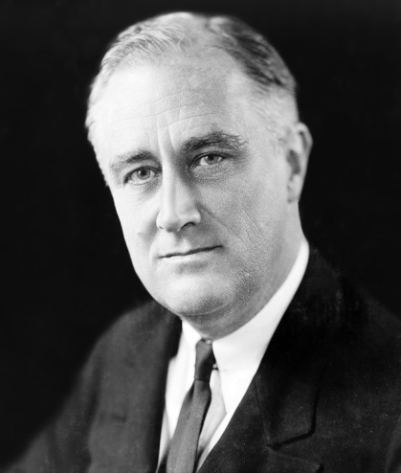
After being elected President of the United States in 1932, Franklin Delano Roosevelt had no sure plan for government under his leadership. Nevertheless, the new President’s optimism and willingness to experiment won him the support of the American people. He had promised, “a new deal for the American people,” and he kept his word. The term New Deal came to refer to the relief, recovery and reform programs of FDR’s administration that were aimed at combating the Great Depression.
From his inauguration in March through June 1933, a period known as the hundred days, Roosevelt pushed program after program through Congress to provide relief, create jobs, and stimulate economic recovery. He based some of these programs on the work of federal agencies that had controlled the economy during World War I and on agencies set up by states to ease the Depression. Former Progressives figured prominently, inspiring New Deal legislation or administering programs.
FDR’s first step was to restore the public confidence in the nation’s banks. On March 5, 1933, he ordered banks to close for the next four days. He then pushed Congress to pass the Emergency Banking Act, which was approved on March 9. The act authorized the government to inspect the financial health of all banks. Many Americans had been terrified by the prospect of losing all their savings in a bank failure. By his actions, FDR hoped to assure the American people that their banks would not fail. Indeed, government inspectors found that most banks were healthy, and two thirds had reopened by March 15.
After the brief “bank holiday,” Americans regained confidence in the banking system. They began to put more money back into their accounts than they took out. These deposits allowed banks to make loans that would help stimulate the economy. Congress increased public confidence further by passing the Glass-Steagall Banking Act of 1933. It established a Federal Deposit Insurance Corporation (FDIC) to insure bank deposits. Congress also moved to correct problems that led to the stock market crash. In 1934, Congress set up the Securities and Exchange Commission (SEC) to regulate the stock market. Congress also gave the Federal Reserve Board power to regulate the purchase of stock on margin.
FDR’s next step was to help overburdened local relief agencies. He persuaded Congress to establish a Federal Emergency Relief Administration (FERA), which sent funds to those agencies. To help people who were out of work, the FERA also put federal money into public works programs, government-funded projects to build public facilities. One of these programs, set up in November 1933, was the Civil Works Administration (CWA). The CWA put the unemployed to work building or improving roads, parks, airports, and other facilities. The agency was a tremendous morale booster to its 4 million employees.
The Civilian Conservation Corps (CCC) became FDR’s favorite program. Established in March 1933, the CCC put more than 2.5 million young, unmarried men to work maintaining forests, beaches, and parks. CCC workers earned only $30 a month, but they lived in camps free of charge and received food, medical care, and job training. Eleanor Roosevelt persuaded the CCC to fund similar programs for young women. Public works programs also helped Native Americans. New Deal funds were used to hire Native American workers to build schools, hospitals, and irrigation systems. The Indian Reorganization Act of 1934 ended the sale of tribal lands begun under the Dawes Act (1887) and restored some lands to Indian owners.
The sharp decline of industrial prices in the early 1930s had caused many business failures and much unemployment. The National Industrial Recovery Act (NIRA) of June 1933 sought to bolster those prices. The NIRA established the National Recovery Administration (NRA), which set out to balance the unstable economy through extensive planning. This planning took the form of industry-wide codes to spell out fair business practices. The federal codes regulated wages, restraining wage competition. They controlled working conditions, production, and prices, and set a minimum wage. They gave organized labor collective bargaining rights, which allowed workers to negotiate as a group with employers.
To this day, one of the most visible parts of the NIRA’s efforts is the work carried out by its Public Works Administration (PWA). Directed by Secretary of the Interior, the PWA launched projects ranging from building dams in Washington state, to New York City’s Triborough Bridge, to the causeway that connects Key West to the Florida mainland.
The National Housing Act of 1934 established the Federal Housing Administration (FHA), a government-owned corporation. The FHA, which still exists today, was created to improve housing standards and conditions, to insure mortgages, and to stabilize the mortgage market. Many farmers were also losing their homes and their land because of the low prices they received for their products. The Agricultural Adjustment Act (AAA), set up in May 1933, tried to raise farm prices through subsidies, or government financial assistance. The AAA used proceeds from a new tax to pay farmers not to raise certain crops and livestock. Lower production, it was hoped, would cause prices to rise.
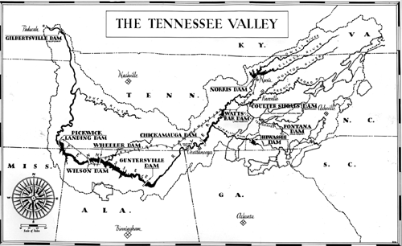
One public works project proved especially popular. The Tennessee Valley Authority (TVA), created in May 1933, helped farmers and created jobs in one of the country’s least developed regions. By reactivating a hydroelectric power facility started during World War I, the TVA provided cheap electric power (in cooperation with the Rural Electrification Administration), flood control, and recreational opportunities to the entire Tennessee River valley.

