American History Name:
Mrs. Barnes Date:
Sources: America (2003); The Twentieth Century by Howard Zinn (2003) Block:
Social Effects of the Great Depression
Not everyone felt the impact of the Great Crash immediately. Many Americans thought the Depression that followed would not last. For them, reality hit in 1931 or 1932. As hard time spread to all levels of society, a song from a 1932 Broadway revue became a theme song of the times:
“Once I built a railroad,
Made it run,
Made it race against time. Once I built a railroad,
Now it’s done,
Brother, can you spare a dime?”

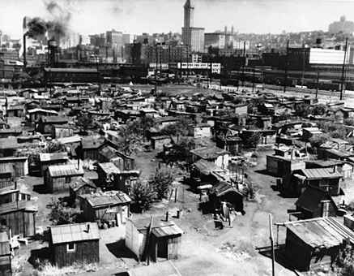
Imagine that the bank where you had a savings account suddenly closed. Your money was gone. Or your parents lost their jobs and could not pay the rent or mortgage. One day you came home to find your furniture on the sidewalk—you had been evicted. People at all levels of society faced these situations. Over five thousand banks closed and huge numbers of businesses, unable to get money, closed too. Those that continued laid off employees and cut the wages of those who remained, again and again. Professionals and white-collar workers, who had felt more secure than laborers, suddenly were laid off with no prospects of finding another job. Those whose savings disappeared found it hard to understand why banks no longer had the money they had deposited for safekeeping. Industrial production fell by 50 percent, and by 1933 perhaps 15 million people were out of work (some one-fourth to one-third of the population).
The hardest hit were those at the bottom of the economic ladder. Some unemployed laborers, unable to pay their rent, moved in with relatives. Others drifted. In 1931, census takers estimated the homeless in New York City alone at 15,000. Homeless people sometimes built shanty towns, with shacks of tar paper, cardboard, or scrap metal. These shelters of the homeless became known as Hoovervilles, mocking the President, whom people blamed for the crisis.
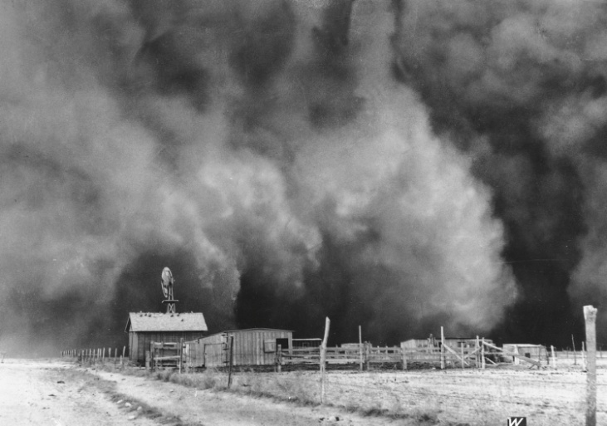
A women living in Oklahoma visited one Hooverville: “here were all these people living in old, rusted-out car bodies,” she noted. “There were people living in shacks made of orange crates. One family with a whole lot of kids were living in a piano box.”
Farm families suffered as low food prices cut their income. There were millions of tons of food around, but it was not profitable to transport it in order to be able to sell it. When they could not pay their mortgages, they lost their farms to the banks, which sold them at auction. In the South, landowners expelled tenant farmers and sharecroppers. In protest against low farm prices, farmers dumped thousands of gallons of milk and destroyed other crops. These desperate actions shocked a hungry nation.
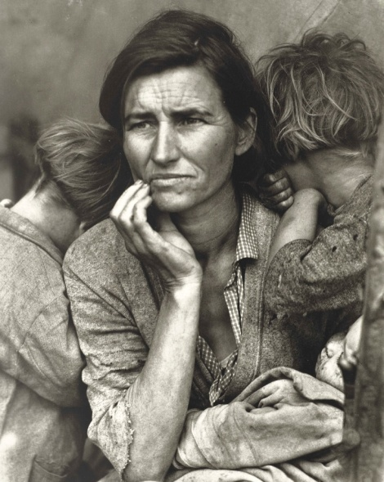
For thousands of farm families in the Midwest, the harsh conditions of the Depression were made even more extreme by another major crisis of the decade. This one was not economic, but environmental. It was the Dust Bowl, a region in the Great Plains where drought and dust storms took place for much of the 1930s. Low farm prices and terrible weather caused many families to sell their farms or see them taken away. More than 440,000 people left Oklahoma during the 1930s. Nearly 300,000 left Kansas. Thousands of families in Oklahoma, Texas, Kansas, and other southwestern Plains states migrated to California. Many found work on California’s farms as laborers. About 100,000 of the Dust Bowl migrants headed to cities, such as Los Angeles, San Francisco, and San Diego. One woman, a photographer named Dorothea Lange, witnessed their arrival and told their story to the rest of America.
Lange’s photographs showed the world the desperation and bravery of whole families reduced to picking peas in the sun and sleeping in cars or makeshift shelters. The pictures stirred public attention and helped win aid for workers. Lange’s work helped bring about the creation of government migrant camps and also inspired John Steinbeck’s Depression-era novel The Grapes of Wrath.
As the Depression wore on, it took a serious physical and psychological toll on the entire nation. Unemployment and fear of losing a job caused great anxiety. People became depressed; many considered suicide, and some did take their own lives. “No one has starved,” President Hoover declared, but some did, and thousands more went hungry. Impoverished people who could not afford food or shelter got sick more easily. Children suffered most from the long-term effects of poor diet and inadequate medical care.
“All last winter we never had a fire except about once a day when Mother used to cook some mush or something, “one homeless boy recalled. “When the kids were cold they went to bed. I quit high school, of course.” In the country, people grew food and ate berries and other wild plants. In cities they sold apples and pencils, begged for money to buy food, and fought over the contents of restaurant garbage cans. Families who had land planted “relief gardens” to feed themselves or to barter food for other items.
Living conditions declined as families moved in together, crowding into small houses or apartments. The divorce rate dropped because people could not afford to separate households. Men who lost their jobs or investments could no longer take care of their families. Women who worked were accused of taking jobs away from men and minorities faced increasing discrimination. African Americans continued to migrate from the South, but faced an astronomical unemployment rate of 56%. Because relief programs discriminated against minorities, black churches and black organizations stepped up to take care of them. Food kitchens became popular and the long lines outside were a far cry from the American dream.

