American History Name:
Date:
Source: America (2003) Block:

Civil Rights: Kennedy v. Johnson
As a senator from Massachusetts, John Fitzgerald Kennedy had voted for civil rights measures but never actively pushed the issue. During his presidential campaign, however, Kennedy had sought and won many African American votes with bold rhetoric. In 1960 he proclaimed, “If the President does not himself wage the struggle for equal rights—if he stands above the battle—then the battle will inevitably be lost.”
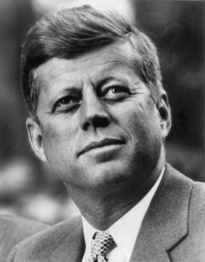
In October 1960, just weeks before the election, Senator Kennedy had a chance to make a powerful gesture of goodwill toward African Americans. Martin Luther King Jr. had been arrested in Alabama and sentenced to four months of hard labor. His family feared for his life in the prison camp. Kennedy called King’s wife, Coretta Scott King, and offered his help. Robert Kennedy, John F. Kennedy’s brother, then persuaded the Alabama sentencing judge to release King on bail.
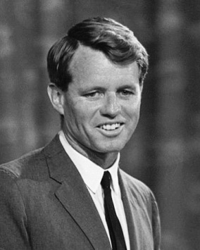
Word of the Kennedys’ actions raced through the black community. Many switched their votes from Nixon to Kennedy. The votes were crucial in Kennedy’s slim margin of victory. Once in office, however, Kennedy moved slowly on issues such as fair housing. He did not want to alienate southern Democratic senators whose votes he needed on foreign policy issues. Yet Kennedy did appoint a number of African Americans to prominent positions. The violent response to the Freedom Rides in 1961 embarrassed the President when he met with Soviet leader Nikita Khrushchev. Observers around the world watched the brutality in Birmingham early in 1963. Aware that he had to respond Kennedy spoke to the American people on television:
“We preach freedom around the world, and we mean it, and we cherish our freedom here at home, but are we to say to the world, and much more importantly to each other that this is a land of the free except for the Negroes? The time has come for this nation to fulfill its promise.”
Robert Kennedy
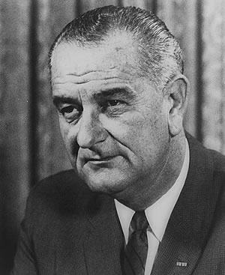
Earlier in his term, Kennedy had proposed a modest civil rights bill. After the crisis in Birmingham, he introduced a far stronger one. It would prohibit segregation in public places, ban discrimination wherever federal finding was involved, and advance school desegregation. Powerful southern segregationists in Congress, however, kept the bill from coming up for a vote.
In November 1963, Kennedy was assassinated. His successor, then-Vice President Lyndon B. Johnson, became the 36th President of the United States. Johnson was a Texan who had voted against civil rights measures early in his congressional career. As Senate majority leader, however, he had worked successfully to get a civil rights bill passed in 1957. Now Johnson used his political skills to pass Kennedy’s bill. In his first public address, he told Congress and the country that nothing “could more eloquently honor President Kennedy’s memory than the earliest possible passage of the civil rights bill.”
Lyndon B. Johnson
After the House of Representatives passed the bill, civil rights opponents in the Senate started a lengthy filibuster, exercising their right of unlimited day-and-night debate. Johnson finally enlisted his former colleague, Republican minority leader Everett Dirksen, to support the rarely use procedure called cloture—a three-fifths vote to limit debate and call for a vote. In June 1964 the Senate voted for cloture. Soon after, the bill passed with support from both Democrats and Republicans.
The Civil Rights Act of 1964 had an impact in many areas, including voting, schools, and jobs. It gave the Justice Department authority to act vigorously in school segregation and voting rights cases. The law’s major sections (called “titles”) included these provisions:
- Title I banned the use of different voter registration standards for blacks and whites.
- Title II prohibited discrimination in public accommodations, such as motels, restaurants, gas stations, theaters and sports arenas.
- Title VI (6) allowed the withholding of federal funds from public or private programs that practice discrimination.
- Title VII (7) banned discrimination on the basis of race, sex, religion, or national origin by employers and unions.
- Title VII (7) also created the Equal Employment Opportunity Commission (EEOC) to investigate charges of job discrimination.
Over the years, the Civil Rights Act of 1964 has helped millions of Americans and affected the nation’s political and business life. However, it did not solve all race-related issues right away.
Many black southerners still had trouble obtaining one basic right: voting. In Selma, Alabama, police and sheriff’s deputies were arresting people just for standing in line to register to vote. To call attention to the voting rights issue, King and other leaders decided to organize a protest march. They would walk from Selma to the state capital in Montgomery, about 50 miles away.
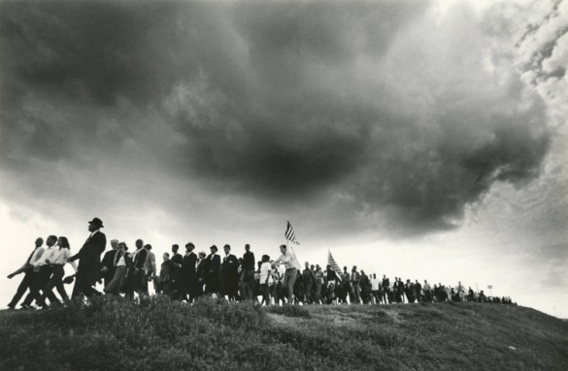
As the marchers set out on a Sunday morning in March 1965, armed state troopers on horseback charged into the crowd with whips, clubs, and tear gas. TV pictures of the attack again shocked many viewers. In response, President Johnson put the Alabama National Guard under federal control. He sent them, along with federal marshals and army helicopters to protect the march route. When the Selma marchers started out again, supporters from all over the country flocked to join. By the time the march reached Montgomery, the ranks had swelled to 25,000 people.
Reacting to Selma, Johnson also went on national television promising a strong new law to protect voting rights. Raising his arms, Johnson repeated, “And…we…shall…overcome!” That summer, despite another filibuster, Congress passed the Voting Rights Act of 1965.
Under the act, federal officials could register voters in places where local officials were blocking registration by African Americans. The act also effectively eliminated literacy tests and other barriers. In the year after the law passed, more than 400,000 African Americans registered to vote in the Deep South.
Together, the Civil Rights Act of 1964 and the Voting Rights Act 1965 created an entirely new voting population in the South. That meant that more black Americans would be elected to political office. Another legal landmark was the Twenty-fourth Amendment to the Constitution, ratified in 1964. It barred the use of the poll tax in federal elections. For some African Americans new laws were not nearly enough. Impatient with the slow pace of progress, they were ready to listen to more militant leaders.

