American History
Mrs. Barnes
Sources: Kenneth C. Davis, Don’t Know Much About History (2003); America (2002)

The Mythic West
Historiography is defined as the writing of history based on examination of evidence and other related sources. In other words, historiography is the interpretation of history. It allows us to not only make sense of historical evidence, but more importantly to understand why history is important. One example of the power of historiography is that of the “mythic West.” Historian Frederick Jackson Turner helped create the myths that surround the American West. Turner’s main argument, or thesis, was that the American frontier, or “the West,” was central to understanding the American story and the American character. Without the West, America simply could not be explained. So what exactly makes up this American myth?
Land Grants and Railroads Americans had begun settling the West decades before the Civil War. But as the Civil War ended, many American citizens and European immigrants moved west in hopes of starting new lives. The land of the frontier was owned by the federal government which meant the U.S. government would be responsible for distributing the land in various ways. In order to encourage people to move west, the U.S. government passed many important pieces of legislation (laws). The Morrill Land Grant Act (1862) established support for the building of state colleges and universities. The federal government would sell land to the states who in turn would sell the land to fund colleges. Many major universities were founded under this grant including Kansas State University, Michigan State University, and Colorado State University.
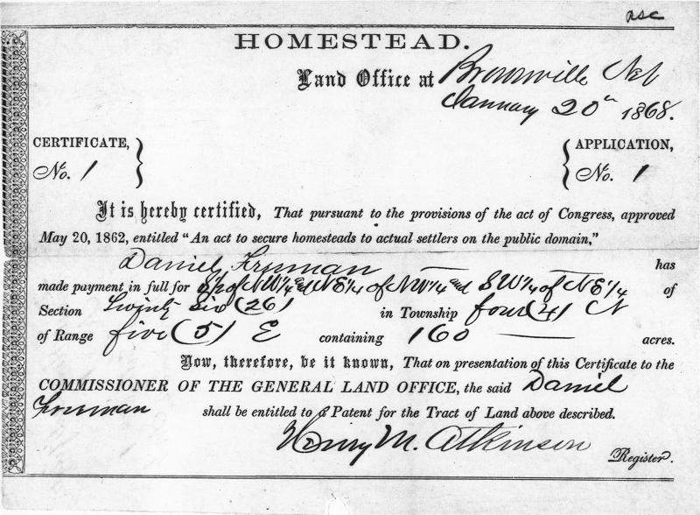
Another important piece of legislation was the Homestead Act (1862). Under this act, the federal government would give citizens 160 acres of land for $10 so long as the citizen met a few requirements: Applicants were at least 21 years of age, or the head of a household
- Applicants had to be U.S. citizens, or in the process of becoming one
- Applicants had to promise to build a house
- Applicants had to live on the land for five years
On top of these initial requirements, tenants living on the land also had to show improvements on the land. On average, this cost upwards of $1,000. Therefore, many settlers failed to meet the expectations. The Timber Culture Act was passed as an extension of the Homestead Act. Under this act, the government would give homesteaders an extra 160 acres so long as they promised to plant trees on 20 percent of the land.
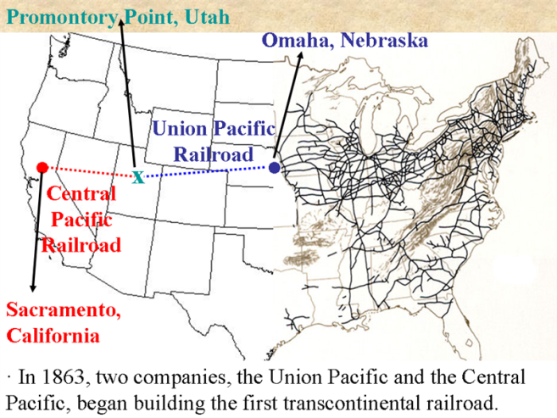
The federal government was also involved in the building of the transcontinental railroad. This railroad would eventually extend from the East coast to the West coast, and therefore new rails had to be built from Omaha, Nebraska to San Francisco, California. In order to complete the project, begun in 1862, the federal government offered loans and land grants to two private companies: the Central Pacific Railroad and the Union Pacific Railroad. The Central Pacific Railroad would start in San Francisco and build east, while the Union Pacific Railroad would begin in Omaha and build west. The two lines would eventually meet at Promontory Point, in modern-day Utah, in May 1869. The building of the railroads was not without its challenges. There was a small labor force who faced dangerous working conditions, materials had to be hauled great distances, and Indian attacks were a constant threat. Gambling halls, saloons, and brothels also created many vices for the men working on the railroad. Known as “Hell on Wheels,” these makeshift “towns” would be transported to the next town down the railroad, leaving behind a framework of a town in a previous site. Despite these problems, the railroad had many benefits; it helped established standardized time zones, improved safety in relation to track gauges and signals, made communication quicker, and carried goods and passengers from one coast to the other with much more ease.
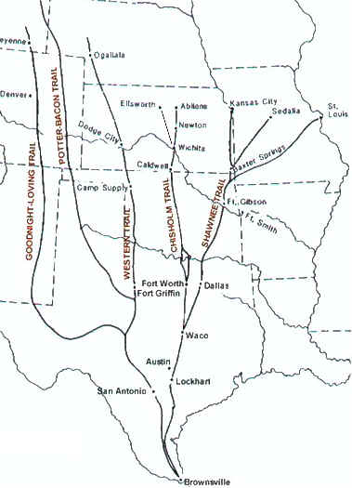
Farming and Ranching Life on the plains was not easy. The land itself was desolate creating an extreme sense of isolation. Weather was extreme and unpredictable rainfall often led to drought and degradation of the soil. Nevertheless, many settlers continued to migrate west. Many were headed to the West coast for mining conquests, while millions of others, mostly Europeans, settled in the Midwest to farm. Even newly freed African Americans, known as Exodusters, left the south for a new life in the west. In order to survive, many farmers had to develop new ways of farming to increase the productivity of the land. Dry farming was one solution. This included planting crops that required little water. New crops like hay, wheat, potatoes, and soy beans began to emerge. In 1902, President Theodore Roosevelt passed the National Reclamation Act in which the federal government paid to irrigate the plains. New technology also helped to make life on the plains somewhat easier. John Deere and Cyrus McCormick introduced mechanical machinery which not only made life easier but also more productive. But, the purchasing of such machinery caused large debts for farmers on the plains which created new issues for them to deal with.
Ranching was equally difficult. American settlers in Texas adopted the ways of Mexican ranchers and profited off the Texas longhorn steer, a combination of Spanish and English cattle. Population booms in the east demanded more beef, so cattle ranchers began making trails from Texas up north to cities like Abilene in Kansas, and Cheyenne in Wyoming. These trails, the most famous being the Chisholm Trail from San Antonio to Abilene, allowed ranchers a quicker and easier route to the markets where they could sell their cattle. These “long drives” required experienced cowboys who could brave the dangerous and exhausting trips. The cattle would graze on the open plains along the trails, helping to fatten them up before getting to market, but devastating crops of farmers along the way. One invention would change all of that. In 1874, Joseph Glidden invented barbed wire allowing farmers on the plains to fence in their land and protect it from grazing cattle. This meant the end of the “open range.” Cattle ranchers were essential to the myths of the Great West. The Wild West towns that sprang up along the cattle trails were the homes to many great myths like lawman James Butler “Wild Bill” Hickok, and the sharp-shooting professional scout Calamity Jane. William “Buffalo Bill” Cody furthered the myths of the West by taking his shows on the road throughout North America and Europe. Visions of the West became romanticized, especially due to tales of battles between “cowboys and Indians.” Frederick Jackson Turner said that these romantic interpretations were essential to creating the character of America. Ideals of individualism, adventure, self-improvement, and conquering the unknown became engrained in the American identity. But Turner’s thesis is incomplete; it does not include the role of women managing homesteads while men were away, or the diversity of groups like the Exodusters who are just as much a part of the story of the West as any other group. Perhaps most importantly though is the absence of the American Indian from the mythical story of the American West. In order to understand American ideals and values, we must also investigate the American treatment of the Indian.

