World History Name:
Mr. Murray Date:
Theories on the Fall of the Old Kingdom Block:
Source: The Western Experience (2007), The Age of God-Kings, Time-Life series (1987)

Fall of the Old Kingdom:
The last known Pharaoh of the Old Kingdom was Pepy II. Pepy II came to power as a boy (some estimates show he was 6 years old!) around 2250 BCE and, according to court records, ruled for more than ninety years. Though such a remarkable tenure should have given him more than enough material to write his history, he was not above taking credit for the feats and accomplishments of his predecessors (those who came before him). Inscribed on one wall of his temple were the names of foreign chieftains (leaders) who had been captured by the pharaoh’s forces—an accomplishment, sure, but it is the same list, verbatim, as an inscription on a tomb of Pharaoh Sahure, who ruled 200 years before Pepy.
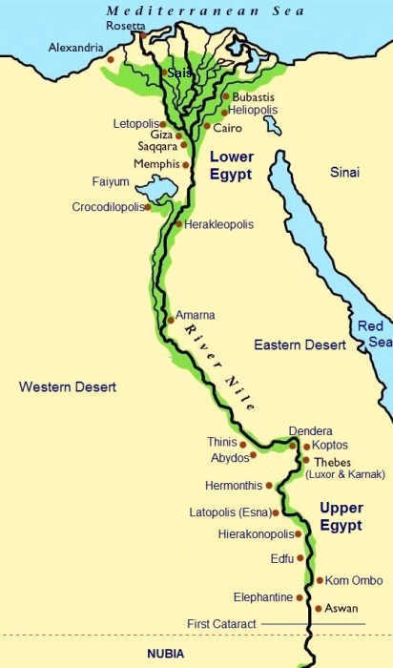
Ultimately. Pepy II’s long reign may have exhausted the resources of his court; his own pyramid complex was massive enough to suit any king, but the surrounding tombs of members of his court were shabby structures built of mud brick, suggesting that the royal funds had fallen on hard times. In contrast, the kings in charge of Egypt’s nomes (small kingdoms throughout the Old Kingdom) were gaining ever more powerful. The growing power of the nome Kings coupled with the decreasing power of the Pharaoh resulted in a crumbling Egypt.

When Pepy II died, the Old Kingdom died with him. Egypt fell into turmoil and chaos. One major issue for the Egyptian people was a long-term drought that severely affected food supply. Crops failed, and mobs of starving homeless Egyptians pillaged the countryside. There was at least one account of cannibalism.

All Egyptian pharaoh’s ruled with authority based on their divine ability to draw forth the blessings of the river, sun, and soil; the agricultural collapse was catastrophic. Within a span of twenty years, no fewer than twenty kings occupied the throne as Egypt lapsed into a period of strife and struggle that would last 100 years. As to be expected, the governments of Egypt were then dominated by force and violence. Kings clashed with each other frequently in attempts to gain more power or land, or both. It was during this time that the capital of Egypt was moved from Memphis to Herakleopolis. Finally, around 2065 BCE, after a century of brawling, the kings from Thebes, another Egyptian kingdom fought their way downriver and defeated the people at Herakleopolis. In a similar fashion as Menes nearly 1000 years earlier, Egypt was once again united under one ruler.

Middle Kingdom:
The period known as the Middle Kingdom in ancient Egypt lasted from roughly 2100-1800 BCE. Throughout the Middle Kingdom, Pharaohs spent time and effort minimizing the power of nome Kings and reestablishing the legitimacy of the Pharaoh. After 150 years, their efforts were fully rewarded, and the Pharaoh was seen as the supreme ruler of Egypt once again.

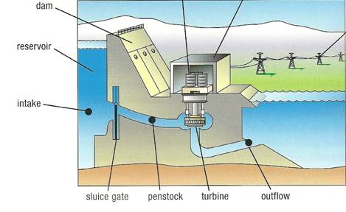
The pharaohs of the Middle Kingdom learned from the mistakes of the Old Kingdom. While they still built religious temples, these temples lacked the luxury and excess which dominated the temples of the Old Kingdom. Perhaps most importantly, they learned the importance of managing the Nile River and became obsessed with water conservation. Irrigation projects were undertaken in a region southwest of Memphis. One such project consisted of a canal 300 feet wide leading from the Nile to a 670 square mile natural depression. The flow of water into that basin was controlled by a dam with gates. When the Nile flooded, the gates would be opened and the basin would fill. The reservoir’s water would help irrigate the land during the dry months.

The pharaohs of the Middle Kingdom were also much more interested in foreign trade than their predecessors. In a region known as Punt to the ancient Egyptians (eastern African coast; modern day Somalia), Egyptians sought rare goods like frankincense, myrhh, and other fragrant resins used by Egyptians during religious ceremonies. To the south of Egypt was a region called Nubia (modern day Sudan) which was rich in gold. This area was eventually brought under the control of Egypt, expanding not only their wealth, but their territory as well. But in other regions, Egypt traded peacefully. Egypt cultivated strong relationships with the early Greek civilization of Minoa, on the island of Crete, and Byblos, in modern day Lebanon. In trading with these two cultures, the Egyptians had access to timber and olive oil in exchange for flax, papyrus, salted fish, ox hide, alabaster, and gold. Despite their trading with foreign nations, the army of the ancient Egyptians in the Middle Kingdom never advanced. This would prove detrimental to the long-term success of Egypt.
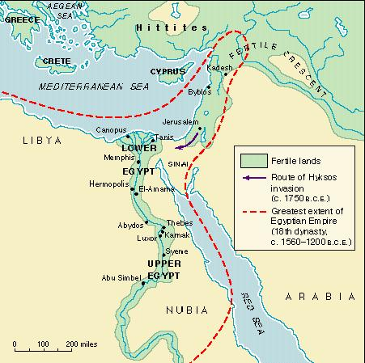
Sometime around 1650 BCE, the delta region of Lower Egypt came to be under the control of a group of people known as the Hyksos. The name means, “rulers of foreign lands,” and the Egyptians further south called them the Aamu, “Asiatics” (that is, from western Asia). They appear to have emigrated from the southern Levant (modern day Israel), the northern portion of Saudi Arabia, Jordan, and from the area known as Palestine. Warriors from Mesopotamia, including the Hyksos, had begun to use helmets and armor, sturdy axes, and composite bows made of laminated strips whose strength and flexibility provided superior range. Egyptian soldiers were still using javelins and simple bows, hardly enough to ward off the advanced militaries to the northwest. The Hyksos had another piece of advanced technology: the two-wheeled chariot. Despite knowing and understanding the wheel, the Egyptians did not use it. Despite living during the height of the Bronze Age, the Egyptians were still dominated by copper. Bronze is an alloy (alloy is a metal made by combining two or more metallic elements to give greater strength or resistance to corrosion), comprised of both copper and tin. Bronze is not only stronger than copper, but it is more fusible and easier to cast. When the Hyksos entered Egypt with bronze tools and blazing chariots, the Egyptian standing army stood no chance. After putting up little resistance and being defeated in one battle, the Egyptians were subject to Hyksos rule for the next 100 years.

By 1520 BCE, Egyptian warriors from Thebes had come north and driven the Hyksos back into their homeland. The period following the departure of the Hyksos is known as the New Kingdom. The period known as the New Kingdom in ancient Egypt lasted from roughly 1500-1000 BCE.

