American History Name:
Date:
Source: adapted from America (2003) Block:

Civil Rights Organizations: Leaders and Strategies
The civil rights movement of the 1950s and 1960s was a grass-roots effort of ordinary citizens determined to end racial injustice in the United States. Although no central organization directed the movement, several major groups formed to share information and coordinate civil rights activities. Each of these groups had its own priorities, strategies, and ways of operating, but they all helped to focus the energies of thousands of Americans committed to securing civil rights for all citizens.
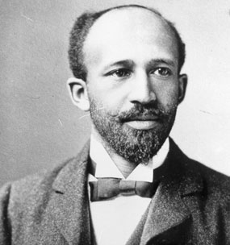
The NAACP, founded in 1909 by W.E.B. du Bois, was behind the Brown v. Board case of 1954. The work of the NAACP centered on challenging laws that prevented African Americans from exercising their full rights as citizens. The NAACP worked to secure full legal equality for all Americans and to remove barriers that kept them from voting. The NAACP found success in getting two anti-lynching bills passed by the House of Representatives in the 1930s. But the NAACP found most of its success when challenging segregation in the courts. In the 1920s and 1930s, the NAACP won a number of legal battles in the areas of housing and education. The NAACP appealed mainly to educated, middle- and upper-class African Americans as well as some liberal white Americans. Critics argued that it was out of touch with basic issues of economic survival faced by many poorer African Americans.
W.E.B. du Bois, Founder of NAACP
One organization that took on economic issues was the National Urban League, founded in 1911. The League sought to assist people moving to major American cities. It helped African Americans moving out of the South find homes and jobs and ensured they would receive fair treatment at work. League workers also looked for migrant families on ship docks and at train stations and found safe, clean apartments for them. They also insisted that factory owners and union leaders allow African American workers the opportunity to learn the skills that could lead to better jobs.
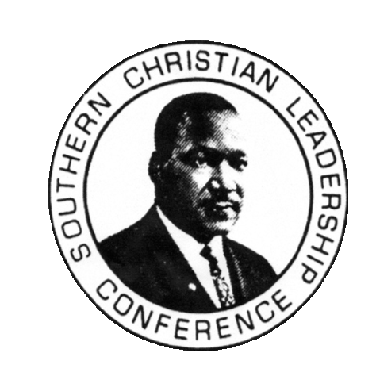
Founded by pacifists in 1942, the Congress of Racial Equality (CORE) was dedicated to bringing about change through peaceful confrontation. It too was interracial, with both African American and white members. During WWII, CORE organized demonstrations against segregation in cities including Baltimore, Chicago, Denver, and Detroit. In the years after the war, CORE director James Farmer worked without pay in order to keep the organization alive. The growing interest in civil rights in the 1950s gave him a new base of support and allowed him to turn CORE into a national organization, one that would play a major role in the confrontations that lay ahead.
In 1957, Martin Luther King, Jr., and other African American clergymen began a new and significant civil rights organization the Southern Christian Leadership Conference (SCLC). SCLC advocated the practice of non-violent protest, a peace way of protesting against restrictive racial policies. Non-violent protestors do not resist even when attacked by opponents. SCLC shifted the focus of the civil rights movement to the South. Earlier organizations had been dominated by northerners. Now southern African American church leaders moved into the forefront of the struggle for equal rights. Among them, MLK, Jr., became a national figure.
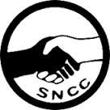
Nonviolent protest was a practical strategy in the civil rights struggle. It also represented a moral philosophy. ‘To accept passively an unjust system is to cooperate with that system; thereby the oppressed become as evil as the oppressor,” King said. “Noncooperation with evil is as much a moral obligation as is cooperation with good.”
A new student organization conceived by the SCLC took a somewhat different approach. The Student Nonviolent Coordinating Committee (SNCC, usually pronounced “snick”), began in 1960 at a meeting in Raleigh, North Carolina, for students active in the struggle. SCLC executive director Ella Baker thought that the NAACP and SCLC were not keeping up with the demands of young African Americans. She wanted to give them a way to play an even greater role in the civil rights movement.
Nearly 200 students showed up for the first SNCC meeting. Most came from southern communities, but some northerners attended as well. Ella Baker and Martin Luther King, Jr., both spoke at the meeting. At the end, the participants organized a temporary coordinating committee.
A month later, student leaders met with Baker and other SCLC and CORE leaders and voted to maintain their independence from other civil rights groups. By the end of the year, the SNCC was a permanent and separate organization. It was interracial at first, though that changed in later years. SNCC filled its own niche in the American civil rights movements. The focus of the civil rights movement shifted away from church leaders alone and gave young activists a chance to make decisions about priorities and tactics. SNCC also sought more immediate change, as opposed to the gradual change advocated by most of the older organizations.

