American History Name:
Date:
Source: The Americans (2003); University of Missouri—Kansas City Block:

Cold War at Home Part II
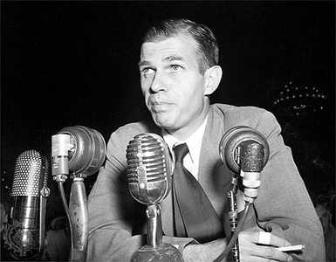
After World War I, and the Communist Revolution in Russia, the Red Scare took hold in the U.S. This Red Scare, or nationwide fear of communists, socialists, anarchists, and other dissidents, gripped the nation with fear. Innocent people were jailed for exercising their civil liberties, which were ignored, under the premise of national security. Following World War II, and the rise of Communist Russia to a major world power, the Red Scare once again crept into the minds and hearts of the American people. Certain incidences fueled the fire; government officials with Communist ties were hunted down by the Loyalty Review Board; Hollywood was under surveillance and everyone was watching to see who was a Communist and who was loyal to the U.S. Two spy cases added to fear that was spreading like an epidemic across the country. One case involved a former State Department official named Alger Hiss.
Alger Hiss
In 1948, a former Communist spy named Whittaker Chambers produced microfilm of government documents that he claimed had been typed of Hiss’s typewriter. Too many years had passed for government prosecutors to charge Hiss with espionage, but a jury convicted him of perjury—for lying about passing the documents under oath—and sent him to jail. A young conservative Republican congressman named Richard Nixon gained fame for pursuing the charges against Hiss. Within four years, of the highly publicized case, Nixon was elected vice president of the United States.
Hiss claimed that he was innocent and that Chambers had forged the documents used against him. However, in the 1990s, Soviet cables released by the National Security Agency seemed to prove Hiss’s guilt.
Another spy case rocked the nation even more than the Hiss case, partially because of international events occurring about the same time. On September 3, 1949, Americans learned that the Soviet Union had exploded an atomic bomb. Most American experts had predicted that it would take the Soviets three to five more years to make the bomb. People began to wonder if Communist supporters in the United States had leaked the secret of the bomb.
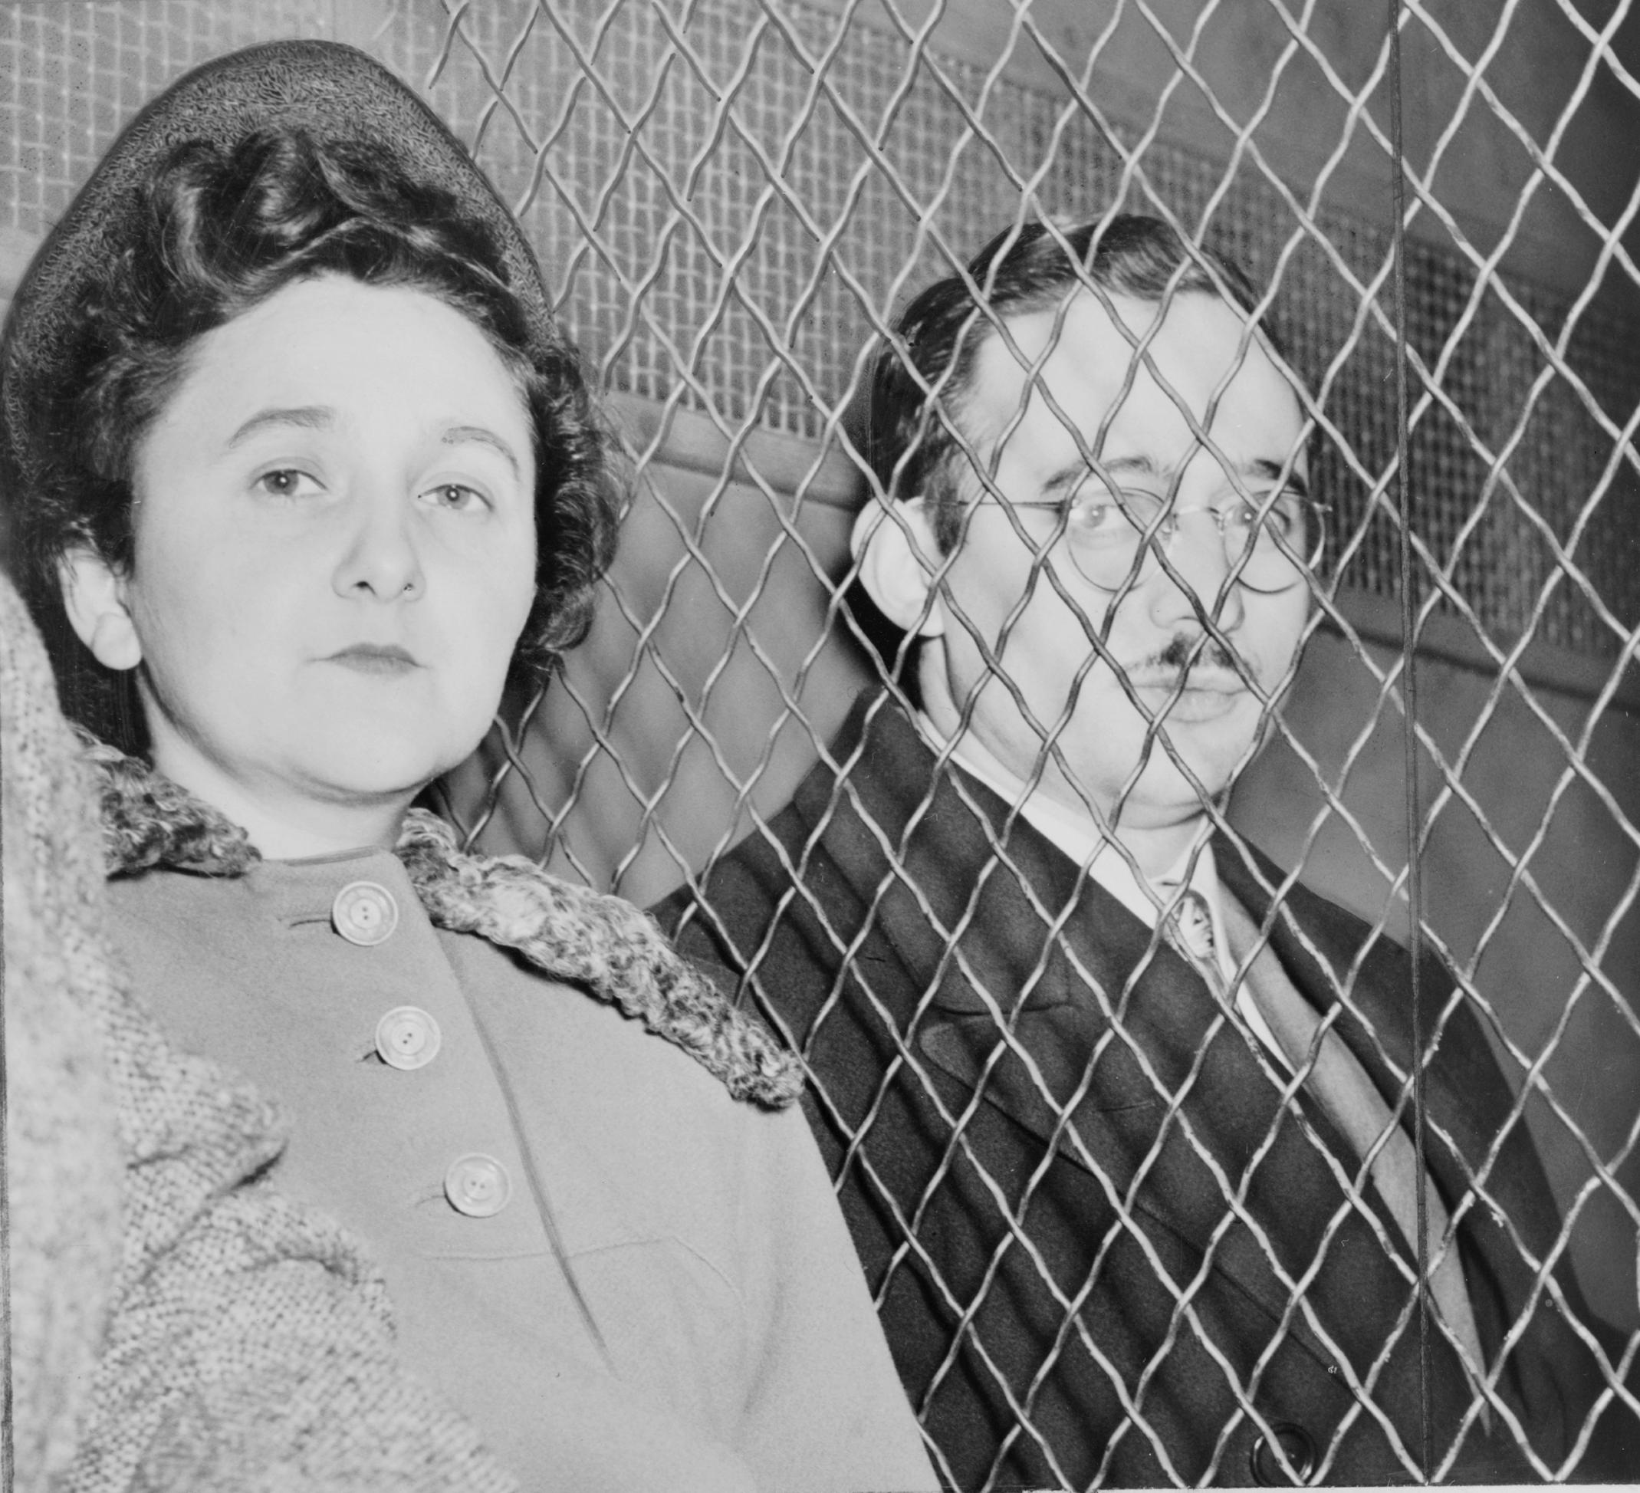
The second spy case seemed to confirm that suspicion. In 1950, the German-born physicist Klaus Fuchs admitted giving the Soviet Union information about America’s atomic bomb. The information probably enabled the Soviet scientists to develop their own atomic bomb years earlier than they would have otherwise. Implicated in the Fuchs case were Ethel and Julius Rosenberg, minor activists in the American Communist Party. When asked if they were Communists, the Rosenbergs denied the charges against them and pleaded the Fifth Amendment, choosing not to incriminate themselves. They claimed they were being persecuted both for being Jewish and for holding radical beliefs. The Rosenbergs were found guilty of espionage and sentenced to death. In pronouncing their sentence, Judge Irving Kaufman declared their crime “worse than murder.” To him, they were directly responsible for one of the deadliest clashes of the Cold War. Kaufman said, “I believe your conduct in putting into the hands of the Russians the A-bomb years before our best scientists predicted Russia would perfect the bomb has already caused, in my opinion, the Communist aggression in Korea…”
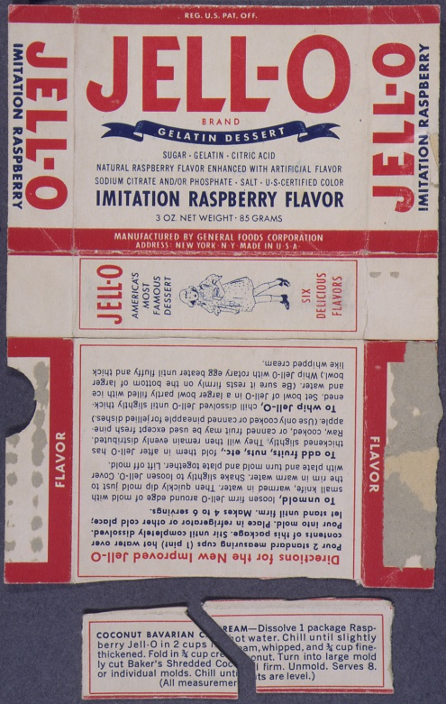
People from all over the world appealed for clemency (mercy, or lenience) for the Rosenbergs. Many considered the evidence and the testimony too weak to warrant the death sentence. The case was appealed to the U.S. Supreme Court, but the Court refused to overturn the conviction. Julius and Ethel Rosenberg died in the electric chair in June 1953, leaving behind two small sons. They became the first U.S. civilians executed for espionage.

Jello box used to identify fellow spies

