World History Name:
Mr. Murray Date:
Alexander the Great Block:

Alexander was born in Macedonia, son of King Philip II, yet struggled to call it “home.” In his early twenties, he would embark on a campaign to capture all of the empire of the east, successfully seizing scores of cities, and naming 16 after himself. He took one wife in Persia (modern-day Iran) and another in Afghanistan. Being raised under Greek influence, Alexander was truly a citizen of the world.
Alexander’s father, Philip II, was a powerful and cunning king who struggled against the Greeks throughout his life. The Peloponnesian Wars (431-404 BCE) were a series of conflicts that set Greek against Greek, scourged cities, toppled governments and temporarily devastated economic life. The semi-unification that occurred after the Persian Wars (492-449 BCE) was completely undone by the inter-state Peloponnesian Wars, leaving a power vacuum on the Greek peninsula. When the Peloponnesian Wars ended in 404 BCE, the victor—if it could be called that—was Sparta. The city’s arch-rival, Athens, had been reduced to near nothing. A once-dominant Greek power, Athens lost her colonies, her city walls, and the majority of her navy. But the rule of Sparta was bloody and short-lived. Over the course of the next 40 years, various Greek city-states would rise to dominance; Thebes, Corinth, and Athens would all become leaders of the peninsula.
Macedonia, the mountainous kingdom to the north of Greece, was considered backward by most Greeks. But it would be a Macedonia king, Philip II, who would ultimately unite the Greeks. The region of Macedonia was primitive—it was a rude, brawling, heavy-drinking country of peasants and landowning warriors. They spoke Greek, but their dialect was so tainted by the barbarian tribes to their north that the Greeks could not understand them.
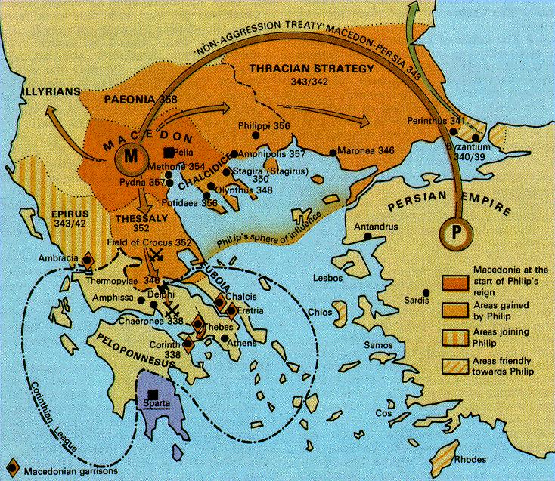
When Philip II was 23 years old, he was named regent for his infant nephew (his brother, the king, had died in battle). Upon being named regent, Philip began to buy off or eliminate his three half-brothers in order to retain his position of power. At the same time he defeated two foreign invasions. Somehow, in all the scuffling, the infant heir vanished, and in 359 BCE, Philip persuaded the army to declare him king.
Philip swiftly brought order to his kingdom. He spread his control north, into Thrace, as well as west and south. Macedonia lacked access to the sea, so Philip captured a coastal colony of Athens. He expanded their treasury by capturing Thracian mines. Wherever he gained territory, Philip founded cities, built roads, promoted farming, and strove to win the loyalty of his new subjects. Even though he sometimes had to use force, Philip preferred to handle matters with as little conflict as possible.
The true instrument of Philip’s success was nonetheless his superb standing army. The Macedonian force was made up of career professionals, and no one was more of a soldier than the king himself. Two competing stories explain Philip’s dedication to the military. One story argues that as a teen, Philip was captured by Greeks and held as a hostage. While a hostage, Philip was exposed to the Greek way of life and especially their military. He watched the Greeks train, he studied their tactics, and learned the ways of their weaponry. He studied the phalanx and the structure of the army as a whole. This story helps to not only explain his love and admiration for the Greek military, but also his disgust and contempt at the Greek way of life. After all, being a hostage rarely makes one appreciate the ways of the enemy. The other story says that teenage prince Philip had been sent to live in the Greek state of Thebes as a guarantee between Macedonia and Thebes of “good faith.” Either way, Philip’s time and experiences in Greece forever impacted the way he viewed the world and would dictate the decisions he made, especially regarding the military. Philip implemented the phalanx in his own military and preferred the quick-striking tactics used by the Greeks. He trained his cavalry in the Greek way and even devised the sarissa—a fifteen-foot spear-like weapon used to strike at the heart of the enemies defensive lines. Philip always fought with his soldiers; in one battle an arrow pierced his right eye, in another his shoulder was smashed.
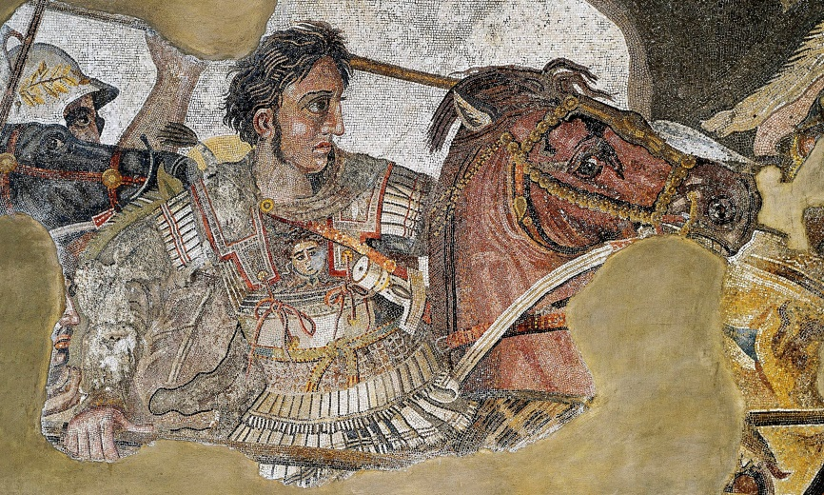
Over the course of his life he acquired 7 wives, mostly for the purposes of political alliances; one of which with he would a son, Alexander. The Battle at Chaeronea (338 BCE) would be the final conflict between Philip’s forces and the Greeks, and would also prove that Alexander was the newest shining star of Macedonia. The combined forces of Thebes and Athens were crushed under the dominance of Philip’s forces. Alexander, at the time only 16 years old, led his own troops within his father’s forces and demonstrated his superior leadership qualities. From there, the Macedonian troops headed south, to the Peloponnesus, and gained control of the entire Greek mainland without any further struggle. Philip then called an assembly of Greek states at Corinth. Here he announced the new rules by which Greece would be governed. From here forward, no Greek would make war against another Greek. All would unite for the purposes of the common good. The states would retain their local autonomy (control over themselves) and would pay Philip no tax or tribute, other than to supply men or ships to a federation of Greek forces commanded by Philip himself. However, Philip still held the ultimate authority and if any state stepped out of bounds, they would have to answer to him.
In 336 BCE, Philip was murdered by a body guard. He had been losing internal support over the last two years, and a series of marriages began to threaten Alexander’s rise to the throne which upset many people in the royal family. As Philip was getting ready to marry off one of his daughters in a political alliance, he was stabbed through the heart. Reasons for his death are unclear; perhaps Olympias, Alexander’s mother, had him killed to ensure Alexander’s rise to the throne; perhaps Persian enemies afraid of the newfound Macedonian dominance sent an assassin; or perhaps the body guard himself was upset with Philip’s leadership and decided to take matters into his own hands. Either way, the king was dead, and now it was Alexander’s turn.
Alexander was born to lead. He was the son of a military man and was raised on the classical works of Greece. He advanced his men based on ability rather than birth. He was impulsive and outgoing and had an intense desire to cultivate friendships. Before battle he would chatter with his men about past expeditions, and afterward, he would visit the wounded. He developed an intense loyalty between himself and his men. Physically, he was not a man of large stature, but something about him enraptured people. As depicted on coins, statues, paintings and mosaics, Alexander’s fair skin, tousled blonde hair and shaven chin radiated; he had curiously innocent eyes; when he entered a room, he both seduced it and mastered it.
After solidifying his rule over the Greek states, Alexander set his sights on Persia, a vast empire to the east. After winning a series of battles, including one against the Persian Emperor, Darius, he traveled south, through Palestine and eventually made his way to Egypt. Here, he was worshipped by the Egyptians like a god. He established the city of Alexandria (which today is the second largest city in Egypt behind Cairo). Alexandria became a booming city with a large and impressive sea port used to transfer in some of the finest goods in the world. Most impressive, though, was the library of Alexandria; thinkers from all over would flock to see and use the great library.
Alexander finally defeated the Persian army at Gaugamela, a flat plain east of the Tigris River. After the defeat, Alexander acquired the main treasury of Persia, an immense hoard of gold and such a wealth of gems, silks, artifacts, and furnishings. 2000 pairs of mules and 500 camels were required to move it all. Alexander paid homage to the great Persian leader Cyrus, a man he deeply admired, then returned to Persepolis (in modern day Iran). As ruler of the Persian Empire, Alexander began to adopt Persian ways while also extending Hellenistic, or Greek, culture to the Persians. He wore traditional Persian dress, yet established schools to teach Greek to Persian children. He appointed Persians to high positions alongside their Greek counterparts. He took his role as Emperor seriously and focused on the improvement of his empire. He issued coins, attended to the army’s needs, built a merchant marine, revamped taxes, opened roads, and dug irrigation canals.
Alexander continued to lead his troops eastward, into Afghanistan and conquered village after village. In one Afghan village he met and married Roxane, the beautiful daughter of a local chieftain and Alexander’s only known female lover. Eventually his troops grew tired of constant travel and warfare and petitioned to quit and go home. Alexander convinced them otherwise, but when a plot to kill Alexander was discovered, several officers, including a close childhood friend, were put on trial and executed. 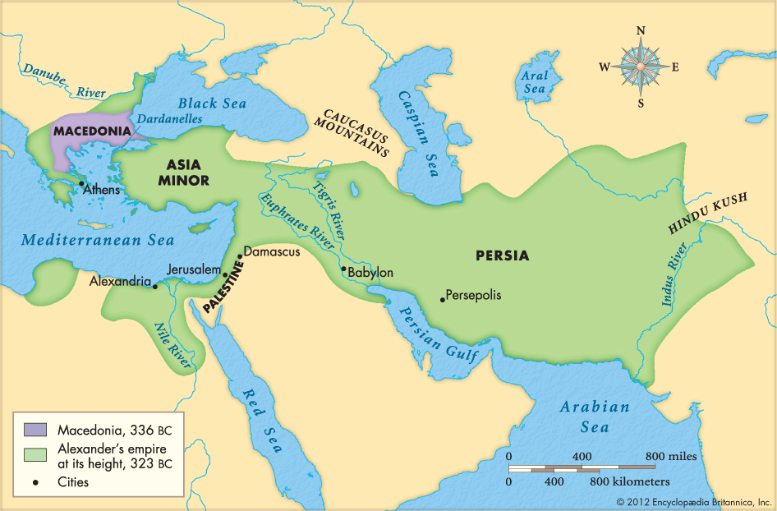
In 323 BCE, Alexander was bitten by a mosquito and contracted a fever. Over the next few days, his fever worsened and he was forced to his couch, barely able to speak. A died a few days later. Few men had such impact on the world as Alexander the Great. He ruled for only thirteen years but conquered more territory than any other warrior before him. He broadened the world’s horizons, mixing races, and cultures, and carrying civilization into a new, more cosmopolitan age. Much of his outlook was seen in the cities he founded. Each city became a little bit of Greece on foreign land. Streets followed a typical grid pattern; theaters were opened and help dramatic festivals; gymnasia and stadiums for competitive sports were built; temples to Zeus and Athena were erected; colonnaded markets were opened for public use; assembly halls where citizens elected local leaders and debated civic issues were constructed.
Upon his death, questions arose about who would be his successor. According to legend, while on his deathbed he was asked who should take over and Alexander is said to have mumbled, “the strongest.” Initially, plans were made to hold the throne in trust for his two legitimate heirs: one, his epileptic half-brother in Macedonia, and that other his infant son, Alexander, whom he had with Roxane. But this plan was doomed from the start. Roxane and baby Alexander were murdered and his brother was positively incompetent. By the early decades of the third century BCE, the empire had been split into fragments. Three large kingdoms were established in the place of Alexander’s empire: Egypt, ruled by Ptolemy I; Macedonia, under the rule of General Antigonus; and the Seleucids, which stretched from modern-day Turkey to the deserts in the Far East.

